

THE JOINT
ARCHITECTURE
FOR
UNMANNED SYSTEMS
Reference
Architecture
Specification

Volume II, Part 1
Version 3.4

April 04, 2008

Architecture Framework
DRAFT

TABLE OF CONTENTS
Title Page
1 Document Organization 1
1.1 Overview 1
1.1.1 Volume I: JAUS Domain Model 1
1.1.2 Volume II: JAUS Reference Architecture 1
1.1.2.1 Reference Architecture Part 1: Architecture Framework 2
1.1.2.2 Reference Architecture Part 2: Message Definition 2
1.1.2.3 Reference Architecture Part 3: Message Set 2
1.1.3 Volume III: JAUS Document Control Plan 3
1.2 Applicable Documents 3
1.2.1 Joint Technical Architecture 3
1.2.2 International System of Units 3
2 Introduction 4
2.1 JAUS Purpose 4
2.2 Technical Constraints 4
2.2.1 Platform Independence 5
2.2.2 Mission Isolation 5
2.2.3 Computer Hardware Independence 5
2.2.4 Technology Independence 6
2.3 JAUS Nomenclature 6
2.4 Definitions 7
3 System Topology 9
3.1 The System Level 10
3.2 The Subsystem Level 10
3.3 The Node Level 10
3.4 The Component/Instance Level 11
3.5 Topology Simplified 12
3.6 Configuration 12
3.6.1 A Priori Configuration 14
3.6.2 Dynamic Configuration 15
4 Component Specification 16
4.1 Component Overview 16
4.2 Component Identification 16
4.2.1 Component Name 16
4.2.1.1 Component Name Format 16
4.2.2 Component Identification Number 16
4.3 Common Component Behaviors 17
4.4 Component Function Specification 17
4.4.1 Single Function 17
4.4.2 Bandwidth Minimization 17
4.5 Component Protocol 17
4.5.1 States 18
4.5.2 Transitions 19
4.5.3 Maps 22
5 Core Component Services 24
5.1 Component Status 24
5.2 Component Control 24
5.3 Service Connections (Deprecated v4.0) 31
5.4 Events 31
5.5 Component Discovery 32
5.6 Node Discovery 32
5.7 Subsystem Discovery 33
5.8 Heartbeat 34
5.9 Time 35
5.10 Payload Interface 36
6 Component Definitions 38
6.1 Command and Control Components 38
6.1.1 System Commander (ID 40) 38
6.1.2 Subsystem Commander (ID 32) 39
6.1.3 ASCII Event Status Service (ID 76) 39
6.2 Communications Components 40
6.2.1 Communicator (ID 35) 40
6.3 Platform Components 41
6.3.1 Global Pose Sensor (ID 38) 41
6.3.2 Local Pose Sensor (ID 41) 42
6.3.3 Velocity State Sensor (ID 42) 43
6.3.4 Primitive Driver (ID 33) 44
6.3.5 Reflexive Driver (ID 43) 47
6.3.6 Global Vector Driver (ID 34) 49
6.3.7 Local Vector Driver (ID 44) 51
6.3.8 Global Waypoint Driver (ID 45) 53
6.3.9 Local Waypoint Driver (ID 46) 55
6.3.10 Global Path Segment Driver (ID 47) 56
6.3.11 Local Path Segment Driver (ID 48) 60
6.3.12 Trim Tab Control (ID 63) 61
6.3.13 Power Supply Status (ID 64) 63
6.3.14 Generator Status (ID 66) 64
6.3.15 Bucket Control (ID 68) 66
6.3.16 Bow Thruster Control (ID 69) 67
6.3.17 Primitive Hydraulics (ID 73) 69
6.3.18 Device Power Manager (ID 74) 70
6.3.19 Acceleration State Sensor (ID 76) 71
6.4 Manipulator Components 72
6.4.1 Definition of Coordinate Systems 74
6.4.2 Primitive Manipulator (ID 49) 75
6.4.3 Manipulator Joint Position Sensor Component (ID 51) 76
6.4.4 Manipulator Joint Velocity Sensor Component (ID 52) 77
6.4.5 Manipulator Joint Force/Torque Sensor Component (ID 53) 77
6.4.6 Manipulator Joint Positions Driver Component (ID 54) 78
6.4.7 Manipulator End-Effector Pose Driver Component (ID 55) 78
6.4.8 Manipulator Joint Velocities Driver Component (ID 56) 80
6.4.9 Manipulator End-Effector Velocity State Driver Component (ID 57) 81
6.4.10 Manipulator Joint Move Driver Component (ID 58) (DEPRECATE IN v4.0) 82
6.4.11 Manipulator End-Effector Discrete Pose Driver Component (ID 59) 83
6.5 Environment Sensing and Modeling Components 84
6.5.1 Visual Sensor (ID 37) 84
6.5.2 Range Sensor (ID 50) 85
6.5.3 World Model Vector Knowledge Store (ID 61) 85
6.5.4 Wind Sensor (ID 70) 87
6.5.5 Water Sensor (ID 71) 88
6.5.6 Atmoshpere Sensor (ID 75) 90
6.6 Planning Components 91
6.6.1 Mission Spooler (36) 92
7 List of Acronyms 98

TABLE OF FIGURES
Title Page
Figure 3-1 - JAUS System Topology 9
Figure 3-2 - JAUS System Communications Topology 9
Figure 3-3 - Example Configuration #1 13
Figure 3-4 - Example Configuration #2 14
Figure 3-5 - Example Configuration #3 14
Figure 5-1 Communicators Provide Single Point of Subsystem Entry 41
Figure 5-2 Wrench Effort Provides Basic Platform Mobility 45
Figure 5-3 Reflexive Tele-Operation Block Diagram 47
Figure 5-4 Global Vector Driving Block Diagram 50
Figure 5-5 Global Vector Driving with Reflexive Driving Block Diagram 50
Figure 5-6 Local Vector Driver Block Diagram 52
Figure 5-7 Local Vector Driver with Reflexive Driving Block Diagram 52
Figure 5-8 Global Waypoint Driver Block Diagram 54
Figure 5-9 Global Waypoint Driving with Reflexive Driving Block Diagram 54
Figure 5-10 Local Waypoint Driving Block Diagram 55
Figure 5-11 Local Waypoint Driving with Reflexive Driving Block Diagram 56
Figure 5-12 - Sample Path Segment with Control Points Shown 57
Figure 5-13 - Effect of Weighting Parameter w1 on Curve Shape 58
Figure 5-14 - Slope Continuity at Path Segment Connection Point 58
Figure 5-15 Path Segment Driving Block Diagram 59
Figure 5-16 Path Segment Driving with Reflexive Driving Block Diagram 59
Figure 5-17 Local Path Segment Driving Block Diagram 60
Figure 5-18 Local Path Segment Driving with Reflexive Driving Block Diagram 61
Figure 5-19 Joint Effort Provides Basic Manipulator Mobility 75
Figure 5-20 Joint Position Sensor Component 76
Figure 5-21 Joint Velocity Sensor Component 77
Figure 5-22 Manipulator Joint Positions Driver Component 78
Figure 5-23 Manipulator End-Effector Pose Driver 79
Figure 5-24 Manipulator Joint Velocities Driver 80
Figure 5-25 Manipulator End-Effector Velocity State Driver Component 81
Figure 5-26 Manipulator Joint Move Driver Component 83
Figure 5-27 Manipulator End-Effector Discrete Pose Driver Component 84
Figure 5-28 Vector Objects 87
Figure 5-29 Mission Planning, Coordination, Execution Process 91
Figure 5-30 Mission Spooler Configuration Example 1 93
Figure 5-31 Mission Spooler Configuration Example 2 93

TABLE OF TABLES
Title Page
Table 4-1 Transition Table 19
Table 4-2: Conditions Table 20
Table 4-3: Action Table 20
Table 4-4: Types of Transitions for Which Entry/Exit Actions Are Executed 22
Table 5-1: Component Control Transitions 26
Table 5-2: Component Control Transition conditions 27
Table 5-3: Component control Transition Actions 27
Table 5-4: Component Discovery Transition Table 32
Table 5-5: Component Discovery Action Table 32
Table 5-6: Node Discovery Transition Table 33
Table 5-7: Node Discovery Action Table 33
Table 5-8: Subsystem Discovery Transition Table 34
Table 5-9: Subsystem Discovery Action Table 34
Table 5-10: Heartbeat Transition Table 35
Table 5-11: Heartbeat Action Table 35
Table 5-12: Time Transition Table 36
Table 5-13: Time Condition Table 36
Table 5-14: Heartbeat Action Table 36
Table 5-15: Payload Interface Transition Table 37
Table 5-16: Payload Interface Condition Table 37
Table 5-17: Heartbeat Action Table 37
Table 6-1: ASCII Event Status Transition Table 40
Table 6-2: ASCII Event Status Condition Table 40
Table 6-3: ASCII Event Status Action Table 40
Table 6-4: Global Pose Sensor Transition Table 42
Table 6-5: Global Pose Sensor Action Table 42
Table 6-6: Local Pose Sensor Transition Table 43
Table 6-7: Local Pose Sensor Action Table 43
Table 6-8: Velocity State Sensor Transition Table 44
Table 6-9: Velocity Sensor Action Table 44
Table 6-10: Primitive Driver Transition Table 46
Table 6-11: Primitive Driver Condition Table 46
Table 6-12: Primitive Driver Action Table 46
Table 6-13: Reflexive Driver Transition Table 48
Table 6-14: Reflexive Driver Condition Table 48
Table 6-15: Reflexive Driver Action Table 49
Table 6-16: Global Vector Driver Transition Table 51
Table 6-17: Global Vector Driver Condition Table 51
Table 6-18: Global Vector Driver Action Table 51
Table 6-19: Local Vector Driver Transition Table 53
Table 6-20: Local Vector Driver Condition Table 53
Table 6-21: Local Vector Driver Action Table 53
Table 6-22: Trim Tab Control Transition Table 63
Table 6-23: Trim Tab Control Condition Table 63
Table 6-24: Trim Tab Control Action Table 63
Table 6-25: Power Supply Status Transition Table 64
Table 6-26: Power Supply Status Condition Table 64
Table 6-27: Power Supply Status Action Table 64
Table 6-28: Generator Status Transition Table 65
Table 6-29: Generator Status Condition Table 65
Table 6-30: Generator Status Action Table 65
Table 6-31: Bucket Control Transition Table 67
Table 6-32: Bucket Control Condition Table 67
Table 6-33: Bucket Control Action Table 67
Table 6-34: Bow Thruster Control Transition Table 68
Table 6-35: Bow Thruster Control Condition Table 68
Table 6-36: Bow Thruster Control Action Table 69
Table 6-37: Primitive Hydraulics Transition Table 70
Table 6-38: Primitive Hydraulics Condition Table 70
Table 6-39: Primitive Hydraulics Action Table 70
Table 6-40: Device Power Manager Transition Table 71
Table 6-41: Device Power Manager Condition Table 71
Table 6-42: Device Power Manager Action Table 71
Table 6-43: Acceleration State Sensor Transition Table 72
Table 6-44: Acceleration State Sensor Condition Table 72
Table 6-45: Acceleration State Sensor Action Table 72
Table 6-46: Wind Sensor Transition Table 88
Table 6-47: Wind Sensor Condition Table 88
Table 6-48: Wind Sensor Action Table 88
Table 6-49: Water Sensor Transition Table 89
Table 6-50: Water Sensor Condition Table 89
Table 6-51: Water Sensor Action Table 90
Table 6-52: Atmosphere Sensor Transition Table 90
Table 6-53: Atmosphere Sensor Condition Table 90
Table 6-54: Atmosphere Sensor Action Table 91
Table 6-55: Mission Spooler Transition Table 96
Table 6-56: Mission Spooler Condition Table 97
Table 6-57: Mission Spooler Action Table 97

Document Organization

Overview
The Joint Architecture for Unmanned Systems (JAUS) is the architecture defined for use in the research, development and acquisition of Unmanned Systems. The overall scope of JAUS is defined in three separate volumes. Volume I is the JAUS Domain Model, Volume II is the JAUS Reference Architecture, and Volume III is the JAUS Document Control Plan. The Reference Architecture Specification is comprised of three parts: Architecture Framework, Message Definition, and Message Set.

Volume I: JAUS Domain Model
The Domain Model (DM) is the model of both known and potential operational requirements that must be supported by the Unmanned System. Two different organizations are defined within the Domain Model: the Acquirer and the Developer. The Acquirer is the organization that determines the operational requirements of the Unmanned System. The Developer is the organization responsible for building the Unmanned System, as defined by the Acquirer.
It is the intent of JAUS that the DM be used to model all requirements, known and anticipated, of the Unmanned Systems. The DM is a tool used by the Developer to understand the requirements of the Acquirer. The Domain Model document is written in the language of the Acquirer.

Volume II: JAUS Reference Architecture
The Reference Architecture (RA) is the technical specification that the Developer shall use to implement JAUS on the Unmanned System. It is also the document that will be used by the Acquirer to assess technical compliance. Therefore, the Reference Architecture document is written in the language of scientists and engineers.
The main purpose of the RA is to describe all functions and messages that shall be employed to design new components. In addition, the RA describes all messages currently defined and the rules that govern messaging. Messaging is the only accepted method used to communicate between components.
In terms of chronological development, capabilities described in the DM will always precede those that appear in the RA. This is because the RA documents only those requirements in the DM that have already gone through a technical evaluation and acceptance process. This process is performed by an organization through the development of models and simulations or through the development of a prototype. In any event, all components defined in the RA can be traced back to a DM capability, whereas the reverse is not always true.

Reference Architecture Part 1: Architecture Framework
Part 1, Architecture Framework, of the Reference Architecture specification provides a description of the structure of JAUS based systems. This document serves as the primary mapping of Domain Model requirements to the JAUS message set. Although message specifics are not stated in the Architecture Framework, guidance for the use of messages to achieve Domain Model specified capabilities is provided in the component discussions.

Reference Architecture Part 2: Message Definition
Part 2, Message Definition, of the Reference Architecture specification specifies the JAUS specific protocol for transmission of JAUS messages. This document specifies the JAUS message header and the types of JAUS messages. The specification focuses on the rules for messaging as opposed to the domain specific semantics contained in the message set itself.

Reference Architecture Part 3: Message Set
Part 3, Message Set, of the Reference Architecture specification specifies the domain specific messages and their exact content. The Message Set is intended to for use within unmanned systems either with or without the preceding two parts of the Reference Architecture Specification.

Volume III: JAUS Document Control Plan
The Document Control Plan (DCP) defines the process used to identify and track requested changes to accepted JAUS documentation. The process for controlling changes to the JAUS documents is based on commercial standards body processes. The DCP defines the roles by committees and its members in the change process as well as providing a historical record of changes and their rationales.

Applicable Documents

Joint Technical Architecture
The Joint Technical Architecture (JTA) is a set of standards that supports interoperability and data interchange among military systems. The reference for the JTA document is:
Department of Defense Joint Technical Architecture (JTA), Version 3.1, March 2000.

International System of Units
JAUS mandates the use of the International System of Units as specified in NIST Special Publication 330, 1991 Edition, “The International System of Units (SI),” Barry N. Taylor, National Institute of Standards and Technology. The URL for this publication is
http://physics.nist.gov/Document/sp330.pdf

Introduction

JAUS Purpose
The purpose of JAUS is to support the acquisition of Unmanned Systems by providing a mechanism for reducing system life-cycle costs. This is accomplished by providing a framework for technology reuse/insertion. JAUS defines a set of reusable “components” and their interfaces. These reusable components not only reduce the maintenance costs of a system, but also dramatically reduce the development costs of any follow-on system(s). Reuse allows a component developed for one Unmanned System to be readily ported to another Unmanned System or to be easily replaced when technological advances.
Technology insertion is achievable when the architecture is designed to be both modular and scaleable. Components that are deemed necessary for the mission of the Unmanned System may be inserted simply by bundling.
JAUS defines components for all classifications of Unmanned Systems from remote control toward autonomous, regardless of application. As a particular system evolves, the architecture is already in place to support more advanced capabilities.

Technical Constraints
Technical constraints are imposed on JAUS to ensure that the architecture is applicable to the entire domain of Unmanned Systems - now and in the future. The constraints are:
Platform Independence
Mission Isolation
Computer Hardware Independence
Technology Independence

Platform Independence
Analysis has shown that Unmanned Systems will be based on a variety of mission requirements, including but not limited to surveillance, reconnaissance, force protection, combat, security, and emergency response. In order for JAUS compliant components to be interoperable, no assumptions about the underlying vehicle are made.

Mission Isolation
The purpose of Unmanned Systems is to gather information, alter the state of the environment, or both. The set of these sensing and effecting tasks are called missions. The purpose of this isolation is the anticipation that many Developers will build their systems to support a variety of missions, possibly with removable mission modules.

Computer Hardware Independence
The growth in the computer industry has been enormous over the past 20 years and there are no indications that the growth will slow down. Future Unmanned Systems must be able to capitalize on commercial advancements in computing and sensor technology. The issue is two-fold:
First, a single Unmanned System must be able to evolve over its product life cycle to accommodate new missions and greater degrees of autonomy. An architecture that imposes a specific hardware implementation reduces the opportunity to take advantage of future technical advancements.
Second, each Unmanned System Developer should have the flexibility to design a computer hardware architecture that meets that particular system’s requirements. Computer hardware that is appropriate for one Unmanned System may not be appropriate for another.
JAUS must maintain computer hardware independence in order to be applicable to all Unmanned Systems.

Technology Independence
The final technical constraint is technology independence. This constraint is similar to computer hardware independence but focuses more on the technical approach rather than the computer hardware. For example, an Unmanned System may use a visual system for numerous purposes. A visual system may provide feedback to the Unmanned Systems operator to support tele-operated driving. A visual system may also perform obstacle detection, target detection, target identification, target tracking, landmark recognition, and so forth. The technology of edge detection is often used in visual systems to perform these functions. However, there may be other techniques besides visual systems and edge detection that could perform obstacle detection. Active Laser Detection and Ranging (LADAR) is one possibility. The point is that there may be multiple technical solutions to a problem. An architecture that is built around a particular technology solution may eliminate a superior alternative.

JAUS Nomenclature
In the language of JAUS, a number of terms are used to delineate position within the overall hierarchy of the system and must therefore, be well understood. These terms describe the different levels of the architecture and define the required internal hierarchical sub-grouping.
- System A system is a logical grouping of subsystems. The system definition provides a functional grouping for the full robotic or unmanned capability. This grouping includes all human interface subsystems and unmanned subsystems common with robotic and unmanned applications.
- Subsystem A subsystem performs one or more unmanned system functions as a single localized entity within the framework of the System. A subsystem shall provide one or more communication command and control capabilities. A mobile subsystem shall execute mobility commands as a single unit and retain a defined center of gravity relative to all articulations and payloads.
- Node A JAUS Node defines a distinct processing capability within a subsystem. A node retains a set of coherent functions and shall provide a node manager component to manage the flows and controls of JAUS message traffic.
- Component A component provides a unique functional capability for the unmanned system. JAUS messages are defined with respect to these capabilities so that context in command and control is provided. A JAUS component resides wholly within a JAUS Node.
- Instance Duplication and redundancy of JAUS Components are provided by Component Instances. All Components are uniquely identifiable using Subsystem, Node, Component and Instance Identifiers.
- Message A JAUS message is comprised of the message header and associated data fields as defined within this document.

Definitions
Message definitions within JAUS use the following terms to define various fields. The following definitions provide clarity and guidance for the understanding of the terms.

RMS: The root-mean-square (RMS), often used as a synonym for the standard deviation of a variant X, is the square root of the mean squared value of x or
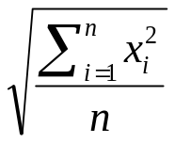
for a discrete distribution, and

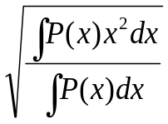
for a continuous distribution.

Physical scientists often use the term root-mean-square as a synonym for standard deviation when they refer to the square root of the mean squared deviation of a signal from a given baseline or fit. RMS is a mean value and not an instantaneous measurement.
Position RMS: The position RMS provides a means of determining the error associated with a reported position. This value is measured over time and therefore not representative of the error any particular position value. It provides a statistical measure of the magnitude of the possible error in 3 dimensions. This value is reported in meters.
Attitude RMS: The attitude RMS provides a means of determining the error associated with a reported attitude. This value is measured over time and therefore not representative of the error any particular attitude value. It provides a statistical measure of the magnitude of the possible error.
Velocity RMS: The velocity RMS provides a means of determining the error associated with a reported speed. This value is measured over time and representative of the error associated with the manner in which speed is recorded and reported. It provides a statistical measure of the magnitude of the possible error.
Presence Vector: JAUS provides for variable length messages. These messages either have repeating data or have a mixture of required and optional data fields. The Presence Vector is used to indicate which of the optional data fields are included. Presence Vector bits are set to one (1) to indicate the optional field is present. The bit is set to zero (0) to indicate the field is not present. Reserved bits shall be set to zero (0).
Data Validity: The Data Validity field in JAUS messages indicates if the originator of the message had sufficient information to populate the fields indicated accurately. This field is independent of the Presence Vector. This field typically uses an identical mapping as the Presence Vector when a Presence Vector is defined. A set bit (‘1’) indicates data validity where a clear bit (‘0’) indicates a possibly invalid field.

System Topology
Section 2.3 introduced several JAUS hierarchical terms: System, Subsystem, Node, Component and Instance. A graphical representation of how each element fits into the JAUS system topology is shown below in Figure 3-1.
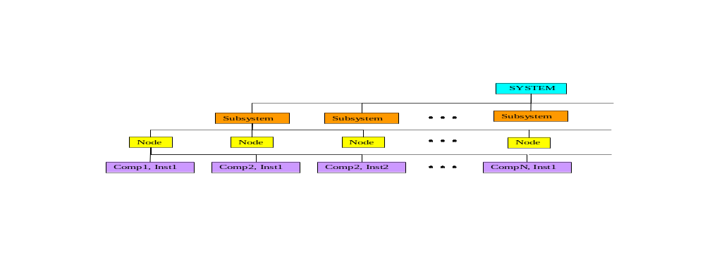
Figure 3-1 - JAUS System Topology
Another way to show how JAUS elements can be assembled to create a JAUS system is shown in Figure 3-2:
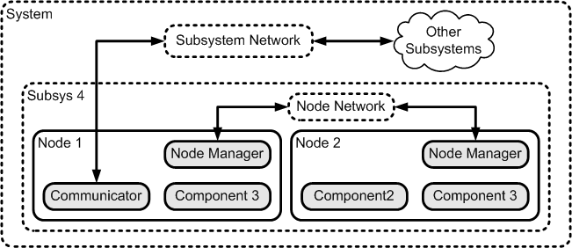
Figure 3-2 - JAUS System Communications Topology

The System Level
A System is a logical grouping of one or more subsystems. A system would normally be grouped in such a manner as to gain some cooperative advantage between the constituent subsystems. An example system might group the following subsystems:
An operator control unit (OCU)
One or more signal repeater subsystems
One or more vehicle subsystems working towards a common goal

The Subsystem Level
A subsystem is an independent and distinct unit. The unit may consist of any number of computer nodes and software components necessary to support its functional requirements. The overall collection of nodes and components in the subsystem, are the parts of the unit that shall comply with the JAUS RA. Examples of subsystems include:
An operator control unit,
An unmanned ground mobility platform (bulldozer, tractor, ground shuttle, etc.),
An unmanned air vehicle (fixed wing, rotary wing, missile, etc.),
An unmanned undersea vehicle (swimmer, crawler, mobile mine, etc.),
An unmanned surface vehicle (boat, ship, etc.),
An unmanned stationary sensor (seismic anomaly detector, data repeater, etc.),
A surveillance system (thermal imager, video camera, etc.),

The Node Level
A node is composed of all the hardware and software assets necessary to support a well-defined computing capability within the subsystem. A node is often treated as a “black-box” containing all the hardware and software necessary to provide a complete service. Examples of nodes within a subsystem might be:
A mobility controller
A world modeling computer
A vision processor
A master controller
A payload controller
From a hardware perspective, a node consists of the computing and interface resources required to support its software components and their interaction with each other, the rest of the subsystem, and any devices they operate. A node may be implemented on one or more interconnected computing elements as determined by the system engineer and as required to provide its function. A node connects to the devices it operates using the hardware and software techniques required by the device itself and device’s own level of computing capabilities, if any. Separate nodes may be interconnected using a wide variety of hardware and software techniques such as serial networks (Ethernet, 1553, CAN, RS232, etc.) or shared bus (e.g. VME, PCI, etc.) or common memory areas. A node is often identified by its existence as a separate entity on a network that interconnects the nodes in a subsystem (e.g., it has a network address).
From a software perspective, a node consists of the software components that run on the node and it is therefore, highly scaleable. A single node could be loaded with all the software necessary to control the whole subsystem, or many nodes could be installed so as to break the job down into more manageable pieces. Detailed configuration is the task of the systems engineer.

The Component/Instance Level
A component is the lowest level of decomposition in the JAUS hierarchy. A component is a cohesive software unit that provides a well-defined service or set of services. Generally speaking, a component is an executable task or process. All of the components currently supported by JAUS are specified in Chapter 5.
Component redundancy is supported, by allowing multiple instances of a component to run on the same node. The JAUS ID of each instance of a component serves to distinguish between these instances. While instances of the same component share an identical interface they may vary in implementation.

Topology Simplified
Now that the five most elementary JAUS terms have been defined, a simple and direct statement can be made that gets to the heart of how they work together —
- A subsystem is composed of component software, distributed across one or more nodes.
From a systems engineering standpoint, this last statement is significant in that it implies, yet does not specify. Since configurations can be virtually unlimited, node or component interface boundaries are not dictated. This is one of the key aspects of JAUS flexibility.

Configuration
One of the principal goals of JAUS is to provide a level of interoperability between intelligent systems that has been missing in the past. Towards this end, JAUS defines functional components with supporting messages, but does not impose regulations on the systems engineer that govern configuration.
JAUS does have one absolute, unwavering requirement that can effect configuration. It is:
- To achieve the desired level of interoperability between intelligent computing entities, all messages that pass between JAUS defined components (over networks or via airwaves), shall be JAUS messages.
The statement above introduces JAUS messages, which are explained in detail in the Reference Architecture Specification Parts 2 and 3. For now, just consider a message as a means of exchanging information. A close examination of this statement reveals that “messages” pass between “components” via some communications medium. It is important to understand that this restriction only applies to JAUS messages.
Figure 3-3 presents an example configuration that is intended to explain further. The diagram depicts two JAUS defined components in blue boxes, a user defined component in green, a dedicated hardware device in yellow and a data storage area in brown.
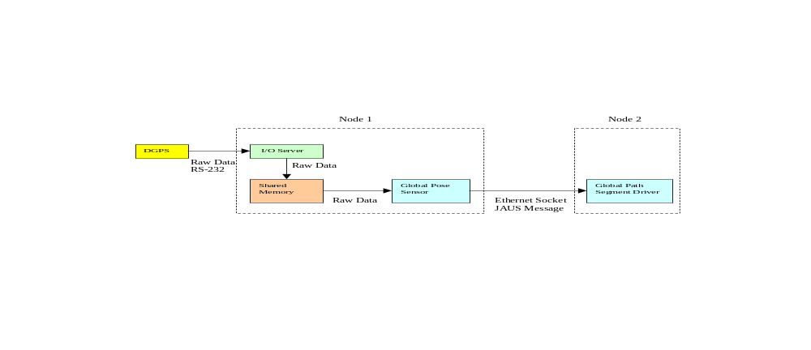
Figure 3-3 - Example Configuration #1

- Node-1 is configured as a Positioning unit and is dominated by the Global Pose Sensor component. It also supports an I/O server task and a shared memory area. The Differential Global Positioning System (DGPS) is configured as a dedicated device within the node. The DGPS is setup in streaming mode so that positioning data is sent out over RS-232 at some regular interval.
- Node-2 is configured as a Path Driving unit and is dominated by the Global Path Segment Driver component. It relies on Global Pose Sensor messages to perform its path-tracking task.
- The I/O server’s job is to listen to the RS-232 COM port and send each received data stream to shared memory after it arrives.
- The Global Pose Sensor component task reads shared memory whenever necessary to get the latest DGPS information.
Important Note: So far all of the data is in raw (non-JAUS) format because typically dedicated sensors, like the DGPS, do not support JAUS messages.
- When the Global Pose Sensor component completes its position calculations, it sends a JAUS formatted Global Pose Sensor message to Node-2. This sequence loops continually.
Notice that although the streaming data coming from the DGPS to the I/O server and on to shared memory is not in JAUS format, that the interoperability rule remains unbroken. Only when data is sent between JAUS defined components, must it be formatted into a JAUS compatible message.
Two simpler variations on the example configuration are depicted by Figure 3-4 and Figure 3-5. Numerous other configurations are also possible.
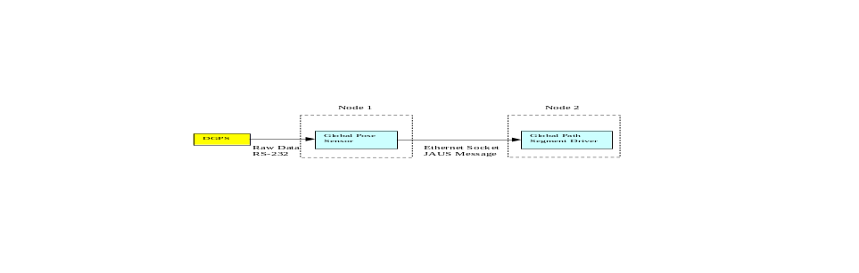
Figure 3-4 - Example Configuration #2
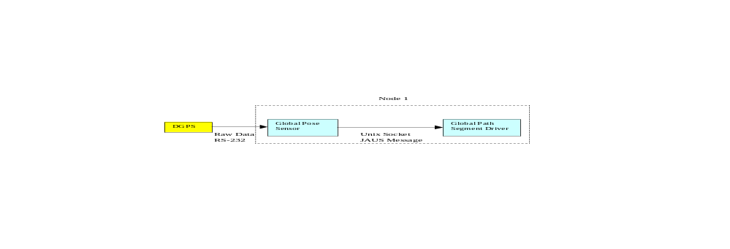
Figure 3-5 - Example Configuration #3
Each of the three configurations will work equally well. Which one is used is entirely the decision of the systems engineer. Configuration is an engineering function and is not mandated by JAUS. As long as the configuration employed does not pose any impediment to JAUS interoperability, the systems engineer is free to employ the most efficient design possible.

A Priori Configuration
Previous versions of JAUS embraced a philosophy whereby system, subsystem, node and component configuration parameters are known or determined before they must be implemented. This so-called “a priori” knowledge imposes certain considerations on the system engineer that must be taken into account during design. Some of the more important matters are as follows:
Each subsystem and node must be assigned a unique node number manually
All serial communications must agree on common line control parameters
Each Ethernet socket and the server process IP address must be assigned
All user defined tasks must be defined and assigned a user defined component ID
In multi-vendor projects, vendors must agree upon where node boundaries lie so as not to encounter any functional overlap or deficiency

Dynamic Configuration
This version of JAUS introduces dynamic configuration. See Part 3 for the dynamic configuration messages.

Component Specification

Component Overview
Components represent the lowest level of decomposition within the reference architecture. A component performs a set of operations that have a logical grouping within the context of the domain. Interaction with components is through messages as defined herein. The component’s messages constitute its interface. A subsystem is composed of components that interoperate using the defined message set to complete the tasks they are designed to perform.

Component Identification
The component identification shall be comprised of a component name and identification number.

Component Name
A component shall have a name that is unique to the entire application domain. The naming convention shall follow these guidelines:

Component Name Format
The Component Name Format shall be a single character string derived from American Standard Code for Information Interchange (ASCII) with the characters’ ASCII values ranging from 48 through 57—numbers zero through nine, 65 through 90—upper case alphabetic, 97 through 122—lower case alphabetic, and 95—the underscore character.

Component Identification Number
Every component has a unique ID number, which is defined by the JAUS specification. Within a subsystem, multiple instances of a component are allowed within a node and/or subsystem. Redundant components must either be on separate nodes or use unique instance ID’s within a node. JAUS views component granularity to be at a macro rather than micro level. JAUS is not a device architecture, so components are not associated with a device; rather, a component defines a function of the subsystem. A component can interface to devices, but this interface is outside the scope of JAUS. Aspects of component execution on their host computing resource such as scheduling, address space protection, fault tolerance, etc., are also outside the scope of this architecture.

Common Component Behaviors
JAUS defines a core set of messages and states and the behaviors associated with these messages. The core messages and their behaviors form a template for developing JAUS components.

Component Function Specification

Single Function
A component shall perform a single cohesive function. The scope of a component’s function should be the one that has been broken down into a primitive function to the point where it is not advantageous to divide it further.

Bandwidth Minimization
The optimal component function shall be defined such that the subsequent interfaces will minimize communication bandwidth.

Component Protocol
The protocol behavior for each component is described in the form of a finite state machine. The finite state machine describes the state of the component and its behavior in response to an input message (external stimuli) or internal event (internal stimuli). The state machines are described diagrammatically as shown in Figure 4-6, and consist of three main elements:
- States, described as rectangles with rounded corners, represent the situations during the life of a component. At any given time, a component is said to be in a state that satisfies some condition, performs come activity, or waits for some stimulus.
- Transitions, described by labeled and directed arrows, represent state changes from a single source state to a single destination state.
- Maps, described as rectangles with sharp corners, represent a grouping of states that share some common behavior.
TransactionMap

Init

Prepared

Done

A

C

D

B

Figure 4-6 Protocol State Machine

States
Each state is given a name by which it can be uniquely identified. A special state called the pseudo-start state is described as a small filled circle. This state contains an arrow that points to the initial state, the state that the component is in when it first comes to life.
Each state may correspond to some ongoing activity that is described using a set of actions called entry and exit actions. These actions are performed when a state is entered and when it is exited, and in the order in which they are listed. Their execution is also conditional on the type of the transition that causes the state to be entered or exited. This is explained in the next sub-section on transitions. The entry action usually starts the activity on entry of the state and the exit action often terminates that activity on exit from the state. But in general, the entry and exit actions may not be related and can be used to perform protocol related functions like sending a message, resetting a timeout or performing operations on stored data. These actions are considered to be atomic and non-interruptible. This kind of activity may also be specified in a fine grained manner with the use of nested states, each of which may have their respective entry and exit actions that are executed in the order in which the states are nested.

Transitions
Transitions cause a state machine to change its state from the source state of the transition to its destination state, and to perform a set of actions called transition actions before transitioning into the destination state. Like entry and exit actions of states, transition actions are also atomic and non-interruptible. The signature of a transition consists of an input message or internal event that triggers the transition, an optional guard condition that must evaluate to true for the transition to be executable, and an ordered sequence of zero or more transition actions. These signatures are listed in tabular form as shown in Table 4-1, Table 4-2, and Table 4-3 below. If the transition is triggered by an internal event, then the trigger for that transition is represented in italics. The transition with trigger Failure in Table 4-1 is an example of a transition that is triggered by an internal event.
Table 4-1 Transition Table
Label | Trigger | Guard | Actions
A | RequestToPrepare |  | sendPrepared
B | SetData | dataWritable | logData,  sendSuccess(LOGGED)
 | SetData | NOT dataWritable | sendAbort(NOWRITE)
C | RollBack |  | clearLog,  sendSuccess(ROLLEDBACK)
 | Commit | NOT isCommit | sendAbort(NOCOMMIT)
 | Failure |  | sendAbort(FAILURE)
D | Commit | isCommit | sendSuccess(COMMITTED)
E | Reset |  | clearLog
F | QueryState |  | sendReportState
Table 4-2: Conditions Table
Condition | Interpretation
dataWritable | True if data can be written
isCommit | True if commit was successful
Table 4-3: Action Table
Action | Interpretation
sendPrepared | Send the prepared message
logData | Write the data to a log
sendAbort(code) | Send the abort message with indicated code
clearLog | Empty the log
sendSuccess(code) | Send the success message with indicated code
sendReportState | Send the report state message

When a state machine is nested, a transition to the enclosing state (or super state) also represents a transition to a nested state only if a nested pseudo start state is used to point to the nested state. In Figure 4-7, the transition labeled A has Prepared.Standby as its destination state due to the presence of the nested pseudo start state in the super state called Prepared. Alternately, a transition may be directed specifically to a nested state as in transition B in Figure 4-7. A nested state may also be a source state to a transition (transition G in Figure 4-7, for example). A transition that has the enclosing state as the source state is equivalent to a transition that has any of the nested states as its source state.

TransactionMap

Init

A

C

Prepared

B

Standby

Ready

G

H

Figure 4-7 Nested States
There are four types of transitions: simple transitions, loopback transitions, push transitions and pop transitions. As the name suggests, a simple transition changes the state of the finite state machine from the transition’s source state to its destination state. A loopback transition causes the finite state machine to re-enter the source state of the transition. That is, the destination state of a loopback transition is its source state. In Figure 4-7 above, the transition labeled A is a Simple transition and the transition labeled B is a loopback transition to the Prepared state. A push transition causes the finite state machine to change its state to the destination state of the push transition in a manner that allows a subsequent pop transition to return the state machine back to the source state of the preceding push transition. This operation is similar to the last in first out (LIFO) operation of a stack. Push and Pop transitions are useful for describing subroutine type operations where control has to be returned to the caller of a subroutine that has completed its execution. Push and Pop transitions are described using unfilled circles marked either Push or Pop, as shown in Figure 4-8 below. In Figure 4-8, the transitions labeled A and B cause the finite state machine to “push” the Blocked state into a stack, while transition labeled C causes the state machine to pop the blocked state from the stack. For example, the sequence of transitions {A, B, C} results in the blocked state being stacked twice and unstacked once, leaving the state machine in a blocked state that is stacked once. The sequence {A, B, C, C} will return the state machine back to the running state.
Map_A

Running

A

B

Blocked
C

Push

Pop

Figure 4-8 Push and Pop Transitions
The execution of entry and exit actions of the source and destination states of a transition is conditional upon the type of the transition. Table 4-4 below shows when these actions can and cannot be executed.
Table 4-4: Types of Transitions for Which Entry/Exit Actions Are Executed
Transition Type | Execute "from" state's Exit Actions? | Execute "to" state's Entry Actions?
Simple Transition | Yes | Yes
Loop back Transition | No | No
Push Transition | No | Yes
Pop Transition | Yes | No

Maps
The Map construct is used to simplify the description of a finite state machine by grouping transitions that are common to a set of states. This is done by assigning transitions that are common to the states defined within a map to a special state called the Default state which is also defined within the same map. In Figure 4-9, transitions labeled E and F are common to all three states Init, Prepared and Done of TransactionMap. This implies that if the state machine is in the Prepared state when the transition labeled E is triggered, the state machine will transition into the Init state. Similarly, if the transition labeled F is triggered while the state machine is in the Prepared state, the state machine will self transition back into the Prepared state after executing the transition actions of the transition labeled F.
TransactionMap

Init

Prepared

Done

Default

A

C

D

E

B

F

Figure 4-9 Default State within a Map

Core Component Services
Each component may support services in this section as core component services.
A component may support any combination of the core services, except that it must support the Component Status and Component Control services.

Component Status
Description
The Component Status messages provide a state machine for component life-cycle state to help clients understand how the component will react to commands and queries.
Vocabulary:
Inputs:
- Code 0002h Shutdown
- Code 0003h Standby
- Code 0004h Resume
- Code 0005h Reset
- Code 0006h Set Emergency
- Code 0007h Clear Emergency
- Code 2002h Query Component Status
Outputs:
- Code 4002h Report Component Status
Internal:
- Failure
- Initialized
Protocol Behavior
Map1
Init
Push State
Pop State
A
H
J
G
D
B
F
Map2
Shutdown
Default
M
L
K
Default
Emergency
Standby
Ready
E
C
I
Failure
Figure 5-10 Component Status State Diagram
Table 5-5: Component Status Transition Table
Label | Trigger | Guard | Actions
A | Initialized
B | Resume | (NOT isControlled) OR requesterInControl
C | Standby | (NOT isControlled) OR requesterInControl
D | Standby | isControlled AND  (NOT requesterInControl)
E | Resume | isControlled AND  (NOT requesterInControl)
F | Reset | (NOT isControlled) OR requesterInControl | init
G | Failure
H | Set  Emergency | isExempt OR  ( (NOT isControlled) OR  requesterInControl ) | storeID
I | Clear Emergency | ( isExempt OR  ( (NOT isControlled) OR  requesterInControl) ) AND  ( requesterInList AND  (NOT isLastIDInTable) ) | removeID
J | Clear Emergency | ( isExempt OR  ( (NOT isControlled) OR  requesterInControl) ) AND  requesterInList AND  isLastIDInTable | removeID
K | Query Component Status |  | sendReportComponentStatus
 | Reset | isControlled AND  (NOT requesterInControl)
 | Standby | isControlled AND  (NOT requesterInControl)
 | Resume | isControlled AND  (NOT requesterInControl)
 | Shutdown | isControlled AND  (NOT requesterInControl)
L | Shutdown | (NOT isControlled) OR requesterInControl
M | Query Component Status |  | sendReportComponentStatus
Table 5-6: Component Status Condition Table
Condition | Interpretation
isControlled | True if Component Control Service is in controlled state.
requesterInControl | True if Component Control Service indicates requester is in control.
isExempt | True if the exemption from command class messages from control behavior has been chosen.
requesterInList | True if the requester ID is in the list of IDs that have set an emergency condition.
isLastIDInTable | True if requester ID is the last ID in the list of IDs that have set an emergency condition.
Table 5-7: Component Status Action Table
Action | Interpretation
init | Reinitialize all the component’s state machines
storeID | Save ID of requester in a list of IDs that have set an emergency condition.
removeID | The ID of the requester sending the Clear Emergency message is removed from the list of IDs that have set an emergency condition.
sendReportComponentStatus | Send a Report Component Status message.
Figure 5-11 Component Status Alternate State Diagram
Default

A

Table 5-8: Component Status Alternate Transition Table
Label | Trigger | Guard | Actions
A | Query Component Status | None | sendReportComponentStatus

Component Control
Description
The Component Control messages allow a client to request exclusive control of a component, and allow clients with higher authority to preempt clients with lower authority.
Vocabulary:
Input:
- Code 0001h Set Component Authority
- Code 000Dh Request Component Control
- Code 000Eh Release Component Control
- Code 0012h: Release Control Request
- Code 0013h: Grant Control
- Code 0014h: Forward Control
- Code 0015h: Switch Control
- Code 2001h Query Component Authority
- Code 200Dh Query Component Control
Output:
- Code 000Fh Confirm Component Control
- Code 0010h Reject Component Control
- Code 0016h: Forward Control Confirmation
- Code 4001h Report Component Authority
- Code 400Dh Report Component Control
Protocol Behavior
Map1
Default
A
B
C
E
D
Not_Controlled
Controlled
Grant Control
G
F
Figure 5-12 Component Control State Diagram
Table 5-9: Component Control Transition Table
Label | Trigger | Guard | Actions
A | Request Component Control | isControllable AND  (NOT inComponentStatusInit) AND  (NOT inComponentStatusShutdown) | sendConfirmComponent(ACCEPTED),  setController
B | Request Component Control | (NOT isControllable) AND  (NOT inComponentStatusInit) AND  (NOT inComponentStatusShutdown) | sendConfirmComponent(NOT_CONTROLLABLE)
C | Request Component Control | isControllable AND  (NOT inComponentStatusInit) AND (NOT inComponentStatusShutdown) AND requesterInControl | sendConfirmComponent(ACCEPTED)
 | Request Component Control | (NOT inComponentStatusInit) AND (NOT inComponentStatusShutdown) AND (NOT requesterInControl) AND  (NOT requesterAuthorityHigher) | sendConfirmComponent(NOTACCEPTED)
 | Request Component Control | (NOT inComponentStatusInit) AND (NOT inComponentStatusShutdown) AND  (NOT requesterInControl) AND requesterAuthorityHigher | rejectCurrentController,  acceptNewController,  setController
 | Switch Control | (NOT inComponentStatusInit) AND (NOT inComponentStatusShutdown) AND  requesterInControl | saveSwitchControllerID
 | Request Component Control | (NOT inComponentStatusInit) AND (NOT inComponentStatusShutdown) AND  (NOT requesterInControl) AND  (NOT acceptControllerSwitch) AND  isRequesterSwitchController | sendConfirmComponent(NOTACCEPTED)
 | Request Component Control | (NOT inComponentStatusInit) AND (NOT inComponentStatusShutdown) AND  (NOT requesterInControl) AND  acceptControllerSwitch AND  isRequesterSwitchController | rejectCurrentController,  acceptNewController,  setController
D | Release Component Control | (NOT inComponentStatusInit) AND (NOT inComponentStatusShutdown) AND requesterInControl | sendRejectComponentControl
 | Timeout | (NOT inComponentStatusInit) AND (NOT inComponentStatusShutdown) | sendRejectComponentControl
 | Timeout | inComponentStatusInit OR inComponentStatusShutdown
E | Query Component Control | (NOT inComponentStatusInit) AND (NOT inComponentStatusShutdown) | sendReportComponentControl
 | Query Component Authority | (NOT inComponentStatusInit) AND (NOT inComponentStatusShutdown) | sendReportComponentAuthority
 | Set Component Authority | (NOT inComponentStatusInit) AND (NOT inComponentStatusShutdown) AND (requesterInControl OR notControlled) | setComponentAuthority
 | Request Component Control | inComponentStatusInit OR inComponentStatusShutdown
F | Request Component Control | (NOT inComponentStatusInit) AND (NOT inComponentStatusShutdown) AND  ( (NOT requesterInControl) AND  (NOT requesterAuthorityHigher) AND  grantControlAllowed) ) | sendReleaseComponentControl
G | Grant Control | (NOT inComponentStatusInit) AND  (NOT inComponentStatusShutdown) AND  requesterInControl AND  controllerGrantsControl | sendConfirmComponent(ACCEPTED),  saveNewControllerID
 | Grant Control | (NOT inComponentStatusInit) AND  (NOT inComponentStatusShutdown) AND  requesterInControl AND  (NOT controllerGrantsControl) | sendConfirmComponent(NOTACCEPTED)

Table 5-10: Component Control Condition Table
Condition | Interpretation
isControllable | True if uninterruptible control is supported
inComponentStatusInit | True if Component Status Service is in init state
inComponentStatusShutdown | True if Component Status Service is in shutdown state
requesterInControl | True if requester is in control.
requesterAuthorityHigher | True if requester has higher authority than current controller
notControlled | True if not currently in exclusive control
saveNewControllerID | Save the ID given as the new controller by the current controller.
requesterGivenControl | True if controller giving control to requester.
acceptControllerSwitch | True if Controller Forwarding (switching) is allowed.
isRequesterSwitchController | True if requester is the controller to be switched to.
grantControlAllowed | True if granting of control by current controller is allowed.
controllerGrantsControl | True if the current controller grants permission to change controllers.
Table 5-11 : Component Control Action Table
Action | Interpretation
sendConfirmComponent(responseCode) | Send Confirm Component Control message
sendRejectComponentControl | Send Reject Component Control message
sendReportComponentControl | Send Report Component Control message
sendReportComponentAuthority | Send Report Component Authority message
setController | Save controller’s ID and authority value
setComponentAuthority | Set the authority value to value indicated in message
acceptNewController | Send a Confirm Component Control message with Accepted to new controller.
rejectCurrentController | Send a Reject Component Control message to the current controller.
sendReleaseComponentControl | Send a Release Component Control to the current controller.
saveNewControllerID | Save the ID given as the new controller by the current controller.
saveSwitchControllerID | Save the ID given as the controller control is being forwarded (switched) to.
The internal Timeout trigger is optional and shall be used to cause control to be released if the controller does not communicate within a specified amount of time. It is recommended that for most applications the timeout be two minutes or longer. If the timeout is not implemented, control shall be maintained indefinitely, even if communications with the controller has been lost.

Service Connections (Deprecated v4.0)
Description
The Service Connection service allows clients to subscribe to changes in the information provided by report messages or to establish a channel of command messages for query/report message pairs or command messages supported by the component.
Vocabulary:
Input:
- Code 0008h Create Service Connection
- Code 000Ah Activate Service Connection
- Code 000Bh Suspend Service Connection
- Code 000Ch Terminate Service Connection
Output:
- Code 0009h Confirm Service Connection
Protocol Behavior

Events
Description
Allow clients to subscribe to changes in the information provided by report messages supported by the component. When a client successfully creates an event, the InternalEvent occurs when the event creation criteria are met, and as a result the matching Event is sent to the subscribing client.
Vocabulary:
Input:
- Code 01F0h Create Event
- Code 01F1h Update Event
- Code 01F2h Cancel Event
- Code 21F0h Query Event
Output:
- Code 01F3h Confirm Event Request
- Code 01F4h Reject Event Request
- Code 41F0h Report Event
- Code 41F1h Event
Internal:
- Event Occurred
- Event Error
Protocol Behavior
Default

A

Figure 5-13 Events State Diagram
Table 5-12: Events Transition Table
Label | Trigger | Guard | Actions
A | Query Events |  | sendReportEvents
 | Create Event | isSupported | createEvent,  sendConfirmEventRequest
 | Create Event | NOT isSupported | sendRejectEventRequest
 | Update Event | eventExists | updateEvent,  sendConfirmEventRequest
 | Update Event | NOT eventExists | sendRejectEventRequest
 | Cancel Event | eventExists | cancelEvent,  sendConfirmEventRequest
 | Cancel Event | NOT eventExists | sendRejectEventRequest
 | Event Occurred | eventExists | sendEvent
 | Event Error | eventExists | sendRejectEventRequest
Table 5-13: Events Condition Table
Condition | Interpretation
isSupported | Parameters are supported.
eventExists | The event specified exists.
Table 5-14: Events Action Table
Action | Interpretation
sendReportEvents | Send Report Events message
createEvent | Create the event
sendConfirmEventRequest | Send Confirm Event Request message
sendRejectEventRequest | Send Reject Event Request message
updateEvent | Update an event
cancelEvent | Cancel an event
sendEvent | Send an event notification

Component Discovery
Description
The Component Discovery service allows clients to determine the identification and message capabilities of a component.
Vocabulary:
Input:
- Code 2B00h Query Identification
- Code 2B03h Query Services
Output:
- Code 4B00h Report Identification
- Code 4B03h Report Services
Protocol Behavior
Default

A

Figure 5-14 Component Discovery State Diagram
Table 5-15: Component Discovery Transition Table
Label | Trigger | Guard | Actions
A | Query Identification | None | sendReportIdentification
 | Query Services | None | sendReportServices
Table 5-16: Component Discovery Action Table
Action | Interpretation
sendReportIdentification | Send Report Identification message
sendReportServices | Send Report Services message

Node Discovery
Description
The Node Discovery service allows clients to determine the identification, message capabilities, and configuration of a node.
Vocabulary:
Input:
- Code 2B00h Query Identification
- Code 2B01h Query Configuration
- Code 2B03h Query Services
Output:
- Code 4B00h Report Identification
- Code 4B01h Report Configuration
- Code 4B03h Report Services
Protocol Behavior
Default

A

Figure 5-15 Node Discovery State Diagram
Table 5-17: Node Discovery Transition Table
Label | Trigger | Guard | Actions
A | Query Identification | None | sendReportIdentification
 | Query Services | None | sendReportServices
 | Query Configuration | None | sendReportConfiguration
Table 5-18: Node Discovery Action Table
Action | Interpretation
sendReportIdentification | Send Report Identification message
sendReportServices | Send Report Services message
sendReportConfiguration | Send a Report Configuration message.

Subsystem Discovery
Description
The Subsystem Discovery Service allows clients to determine identification, message capabilities, and configuration of a subsystem. It also allows clients to determine what other subsystems are known.
Vocabulary:
Input:
- Code 2B00h Query Identification
- Code 2B01h Query Configuration
- Code 2B02h Query Subsystem List
- Code 2B03h Query Services
Output:
- Code 4B00h Report Identification
- Code 4B02h Report Subsystem List
- Code 4B01h Report Configuration
- Code 4B03h Report Services
Protocol Behavior
Default

A

Figure 5-16 Subsystem Discovery State Diagram
Table 5-19: Subsystem Discovery Transition Table
Label | Trigger | Guard | Actions
A | Query Identification | None | sendReportIdentification
 | Query Services | None | sendReportServices
 | Query Configuration | None | sendReportConfiguration
 | Query Subsystem List | None | sendReportSubsystemList
Table 5-20: Subsystem Discovery Action Table
Action | Interpretation
sendReportIdentification | Send Report Identification message
sendReportServices | Send Report Services message
sendReportConfiguration | Send a Report Configuration message.
sendReportSubsystemList | Send a Report Subsystem List message.

Heartbeat
Description
The Heartbeat service allows a client to establish whether a component is reachable.
Vocabulary:
Input:
- Code 2202h Query Heartbeat
Output:
- Code 4202h Report Heartbeat
Protocol Behavior
Default

A

Figure 5-17 Heartbeat State Diagram
Table 5-21: Heartbeat Transition Table
Label | Trigger | Guard | Actions
A | Query Heartbeat Pulse | None | sendReportHearbeatPulse
Table 5-22: Heartbeat Action Table
Action | Interpretation
sendReportHearbeatPulse | Send Report Heartbeat Pulse message

Time
Description
The Time service allows clients to query and set the system time for the component.
Vocabulary:
Input:
- Code 0011h Set Time
- Code 2011h Query Time
Output:
- Code 4011h Report Time
Protocol Behavior
Default

A

Figure 5-18 Time State Diagram
Table 5-23: Time Transition Table
Label | Trigger | Guard | Actions
A | Set Time | (NOT isComponentControlControlled) OR requesterInControl | setTime
 | Query Time | None | sendReportTime
Table 5-24: Time Condition Table
Condition | Interpretation
isComponentControlControlled | Component Control is controlled.
requesterInControl | True if Component Control Service indicates requester is in control.
Table 5-25: Heartbeat Action Table
Action | Interpretation
setTime | Set the time to the specified time.
sendReportTime | Send a Report Time message.

Payload Interface
Description
The Payload Interface service exposes command and informational interfaces.
Vocabulary:
Input:
- Code 0D01h Set Payload Data Element
- Code 2D00h Query Payload Interface
- Code 2D01h Query Payload Data Element
Output:
- Code 4D00h Report Payload Interface
- Code 4D01h Report Payload Data Element
Protocol Behavior
Default

A

Figure 5-19 Payload Interface State Diagram
Table 5-26: Payload Interface Transition Table
Label | Trigger | Guard | Actions
A | Set Payload Data Item | (NOT isComponentControlControlled)  OR requesterInControl | setDataItem
 | Query Payload Interface | None | sendReportPayloadInterface
 | Query Payload Data Item | None | sendReportPayloadDataItem
Table 5-27: Payload Interface Condition Table
Condition | Interpretation
isComponentControlControlled | Component Control is controlled.
requesterInControl | True if Component Control Service indicates requester is in control.
Table 5-28: Heartbeat Action Table
Action | Interpretation
setDataItem | Set the data item specified with the data provided.
sendReportPayloadInterface | Send a Report Payload Interface message.
sendReportPayloadDataItem | Send a Report Payload Data Item message.

Component Definitions
JAUS is comprised of a series of components with well-defined interfaces. A developer can combine and integrate these components in any manner that is seen fit for a particular application. The JAUS components are grouped as follows:
- Command and control components
- Communications components
- Platform components
- Manipulator components
- Environmental sensor components
The components within each of these groupings are described in the subsequent sections of this document.

Command and Control Components
The following components provide a mechanism for system integration at the system and subsystem levels. As such, each of the following command and control components is allowed to output any message to any component and to receive any message from any component.

System Commander (ID 40)
Function:
The System Commander coordinates all activity within a given system.
Description:
The System Commander component has the responsibility of performing the multi-subsystem coordination, issuing commands, and querying status for the system operation. The functions of the System Commander component may be performed by humans or by computer resources, or both. When humans perform the System Commander functions, the human computer interface shall be considered part of the System Commander component.

Subsystem Commander (ID 32)
Function:
The Subsystem Commander coordinates all activity within a given subsystem.
Description:
The Subsystem Commander component has the responsibility of performing the mission planning, issuing commands, and querying status for the subsystem operation. The functions of the Subsystem Commander component may be performed by humans or by computer resources, or both. When humans perform commander functions, the human computer interface shall be considered part of the Subsystem Commander component.

ASCII Event Status Service (ID 76)
Function:
The ASCII Event service reports instantaneous information in human readable text.
Description:
The ASCII Event service provides descriptive info to human operators and it is handy for high level operational data recording. The service accepts the command Set ASCII Event Level to set the class of events for reporting. Currently, eight levels of events enumerated from 0 to 7 are defined. If the event level is set to NONE (0), the service stops report any events.
Note: In order to receive instantaneous information, a client should setup an every-change event on Report ASCII Event Status via Create Event 01F0h.
Vocabulary:
Inputs:
- Code 01F5h: Set ASCII Event Level
- Code 21F5h: Query ASCII Event Level
- Code 21F6h: Query ASCII Event Status
Outputs:
- Code 41F5h: Report ASCII Event Level
- Code 41F6h: Report ASCII Event Status
Protocol Behavior
Default

A

Figure 6-20 ASCII Event Status State Diagram
Table 6-29: ASCII Event Status Transition Table
Label | Trigger | Guard | Actions
A | Query ASCII Event Level | None | sendReportASCIIEventLevel
 | Query ASCII Event Status | isComponentStatusReady | sendReportASCIIEventStatus
 | Set ASCII Event Level | isComponentStatusReady AND requesterInControl | setASCIIEventLevel
Table 6-30: ASCII Event Status Condition Table
Condition | Interpretation
isComponentStatusReady | True if component status indicates ready.
requesterInControl | True if Component Control Service indicates requester is in control.
Table 6-31: ASCII Event Status Action Table
Action | Interpretation
sendReportASCIIEventLevel | Send a Report ASCII Event Level message.
sendReportASCIIEventStatus | Send a Report ASCII Event Status message.
setASCIIEventLevel | Set the ASCII Event Level to the level given.

Communications Components

Communicator (ID 35)
Function:
The Communicator component maintains all data links to other subsystems within a system.
Description:
The communicator component allows for a single point of entry to any subsystem (See Figure 6-21). This specification provides flexibility in communications systems design and implementation.
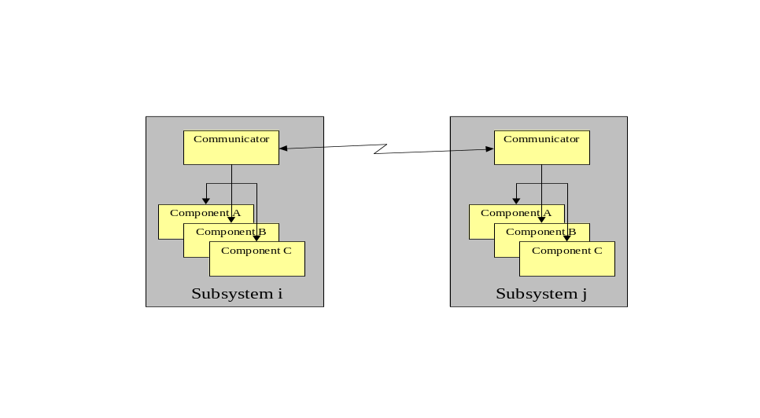
Figure 6-21 Communicators Provide Single Point of Subsystem Entry

Platform Components

Global Pose Sensor (ID 38)
Function:
The function of the Global Pose Sensor is to determine the global position and orientation of the platform.
Description:
The Report Global Pose message provides the position and orientation of the platform. The position of the platform is given in latitude, longitude, and elevation, in accordance with the WGS 84 standard. Platform orientation is as defined in Part 2 of this document.
Vocabulary:
Inputs:
Code 0412h: Set Geomagnetic Property
Code 0402h: Set Global Pose
- Code 2402h: Query Global Pose
- Code 2412h: Query Geomagnetic Property
Outputs:
- Code 4402h: Report Global Pose
- Code 4412h: Report Geomagnetic Property
Protocol Behavior
Default

A

Figure 6-22 Global Pose Sensor State Diagram
Table 6-32: Global Pose Sensor Transition Table
Label | Trigger | Guard | Actions
A | Query Global Pose | None | sendReportGlobalPose
Table 6-33: Global Pose Sensor Action Table
Action | Interpretation
sendReportGlobalPose | Send Report Global Pose message

Local Pose Sensor (ID 41)
Function:
The function of the Local Pose Sensor is to determine the local position and orientation of the platform.
Description:
The Report Local Pose message provides the position and orientation of the platform relative to a local reference frame. The position of the platform is given in Cartesian coordinates x, y, and z, relative to a defined local reference frame. Platform orientation is as defined in Part 2 of this document.
Vocabulary:
Inputs:
- Code 2403h: Query Local Pose
Outputs:
- Code 4403h: Report Local Pose
Protocol Behavior
Default

A

Figure 6-23 Local Pose Sensor State Diagram
Table 6-34: Local Pose Sensor Transition Table
Label | Trigger | Guard | Actions
A | Query Local Pose | None | sendReportLocalPose
Table 6-35: Local Pose Sensor Action Table
Action | Interpretation
sendReportLocalPose | Send Report Local Pose message

Velocity State Sensor (ID 42)
Function:
The Velocity State Sensor has the responsibility of reporting the instantaneous velocity of the platform.
Description:
The velocity state of a rigid body is defined as the set of parameters that are necessary to calculate the velocity of any point in that rigid body. Six parameters are required to specify a velocity state of a rigid body in terms of some fixed reference coordinate system. The first three parameters represent the velocity components of a point in the rigid body that is coincident with the origin of the fixed reference. The second three components represent the instantaneous angular velocity components. It is possible to represent the six velocity state parameters as a screw, about which the rigid body is rotating and translating along at that instant.
The reference frame for the velocity state sensor component is selected as a fixed coordinate system that at this instant is co-located with and aligned with the vehicle or system coordinate system. Thus the message data ‘velocity x’, ‘velocity y’, and ‘velocity z’ represents the current velocity of the subsystem’s control point at this instant. For example if ‘velocity x’ has a value of 3 m/sec and ‘velocity y’ and ‘velocity z’ are zero, then the vehicle is moving in the forward direction at a velocity of 3 m/sec. The message data ‘omega x’, ‘omega y’, and ‘omega z’ represent the actual rate of change of orientation or angular velocity of the vehicle about its coordinate axes.
Vocabulary:
Inputs:
- Code 2404h: Query Velocity State
Outputs:
- Code 4404h: Report Velocity State
Protocol Behavior
Default

A

Figure 6-24 Velocity State Sensor State Diagram
Table 6-36: Velocity State Sensor Transition Table
Label | Trigger | Guard | Actions
A | Query Velocity State | None | sendReportVelocityState
Table 6-37: Velocity Sensor Action Table
Action | Interpretation
sendReportVelocityState | Send Report Velocity State message

Primitive Driver (ID 33)
Function:
The Primitive Driver component performs basic driving and all platform related mobility functions including operation of common platform devices such as the engine and lights.
Description:
This component does not imply any particular platform type such as tracked or wheeled, but describes mobility in six degrees of freedom using a percent of available effort in each direction. Additionally, no power plant (gasoline, diesel, or battery) is implied and the component functions strictly in an open loop manner, i.e., a velocity is not commanded since that requires a speed sensor. Note that the specific actuator commands are not defined by JAUS.
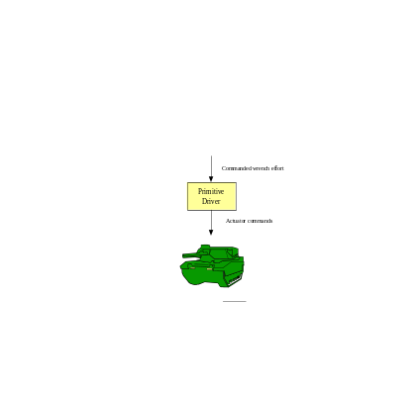
Figure 6-25 Wrench Effort Provides Basic Platform Mobility
Vocabulary:
Inputs:
- Code 0405h: Set Wrench Effort
- Code 0406h: Set Discrete Devices
- Code 2400h: Query Platform Specifications
- Code 2401h: Query Platform Operational Data
- Code 2405h: Query Wrench Effort
- Code 2406h: Query Discrete Devices
Outputs:
- Code 4400h: Report Platform Specifications
- Code 4401h: Report Platform Operational Data
- Code 4405h: Report Wrench Effort
- Code 4406h: Report Discrete Devices
Protocol Behavior
Default

A

Figure 6-27 Primitive Driver State Diagram
Table 6-38: Primitive Driver Transition Table
Label | Trigger | Guard | Actions
A | Query Platform Specifications | None | sendReportPlatformSpecifications
 | Query Wrench Effort | None | sendReportWrenchEffort
 | Query Discrete Devices | None | sendReportDiscreteDevices
 | Query Platform Operational Data | None | sendReportPlatformOperationalData
 | Set Discrete Devices | isComponentStatusReady | setDiscreteDevices
 | Set Wrench Effort | isComponentStatusReady | setWrenchEffort
Table 6-39: Primitive Driver Condition Table
Condition | Interpretation
isComponentStatusReady | True if Component Status Service indicates ready.
Table 6-40: Primitive Driver Action Table
Action | Interpretation
sendReportPlatformSpecifications | Send a Report Platform Specifications message.
sendReportWrenchEffort | Send a Report Wrench Effort message.
sendReportDiscreteDevices | Send a Report Discrete Devices message.
sendReportPlatformOperationalData | Send a Report Platform Operational Data message.
setDiscreteDevices | Set the Discrete Devices values provided by the message.
setWrenchEffort | Set the Wrench Effort values provided by the message.

Reflexive Driver (ID 43)
Function:
The function of the Reflexive Driver is an extension of the primitive driver that provides platform safety and/or stability in addition to basic platform mobility.
Description:
The Reflexive Driver component can be thought of as a filter. It receives a desired motion but is allowed to deviate from the desired motion if the input desired motion would cause the platform to collide with an obstructing object or would compromise platform stability. This component provides a low-level protection for the platform and should not be interpreted as providing a high-level re-planning capability.
The sensors used to determine the platform’s safe operation are not specified. Some examples of sensor input include range information to avoid collisions (i.e., platform safety) and velocity information to avoid vehicle rollover (i.e., platform stability). Figure 6-28 shows one possible implementation of a reflexive driver that uses feedback from a global pose sensor, velocity state sensor, and a range sensor. Note that this example implementation also includes a primitive driver interface. Providing the primitive driver interface allows the system commander to essentially turn off vehicle safety and stability functionality by accessing the primitive driver directly.
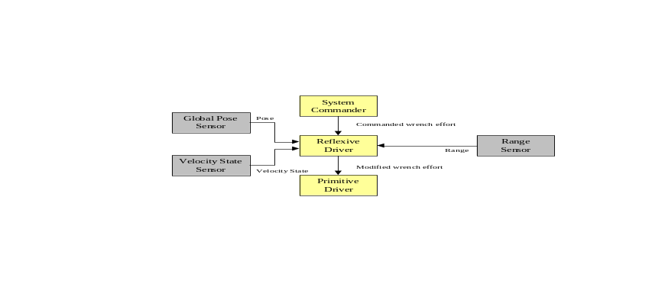
Figure 6-28 Reflexive Driving with Primitive Driving Block Diagram
Vocabulary:
Inputs:
- Code 0405h: Set Wrench Effort
- Code 0406h: Set Discrete Devices
- Code 2400h: Query Platform Specifications
- Code 2401h: Query Platform Operational Data
- Code 2405h: Query Wrench Effort
- Code 2406h: Query Discrete Devices
Outputs:
- Code 4400h: Report Platform Specifications
- Code 4401h: Report Platform Operational Data
- Code 4405h: Report Wrench Effort
- Code 4406h: Report Discrete Devices
Protocol Behavior
Default

A

Figure 6-29 Reflexive Driver State Diagram
Table 6-41: Reflexive Driver Transition Table
Label | Trigger | Guard | Actions
A | Query Platform Specifications | None | sendReportPlatformSpecifications
 | Query Wrench Effort | None | sendReportWrenchEffort
 | Query Discrete Devices | None | sendReportDiscreteDevices
 | Query Platform Operational Data | None | sendReportPlatformOperationalData
 | Set Discrete Devices | isComponentStatusReady | setDiscreteDevices
 | Set Wrench Effort | isComponentStatusReady | setWrenchEffort
Table 6-42: Reflexive Driver Condition Table
Condition | Interpretation
isComponentStatusReady | True if Component Status Service indicates ready.
Table 6-43: Reflexive Driver Action Table
Action | Interpretation
sendReportPlatformSpecifications | Send a Report Platform Specifications message.
sendReportWrenchEffort | Send a Report Wrench Effort message.
sendReportDiscreteDevices | Send a Report Discrete Devices message.
sendReportPlatformOperationalData | Send a Report Platform Operational Data message.
setDiscreteDevices | Set the Discrete Devices values provided by the message.
setWrenchEffort | Set the Wrench Effort values provided by the message.

Global Vector Driver (ID 34)
Function:
The function of the Global Vector Driver component is to perform closed loop control of the desired global heading, altitude and speed of a mobile platform.
Description:
The Global Vector Driver component takes the desired heading of the platform as measured with respect to the global coordinate system and the desired speed of the platform. The desired heading angle is defined in a right hand sense about the Z axis of the global coordinate system (the Z axis points downward) where North is defined as zero degrees. The desired Altitude Above Sea Level (ASL) provides a means through which systems capable of flight can be controlled. For ground-based systems, the Altitude ASL field is ignored. The Global Vector Driver component also receives data from the Global Pose Sensor component and the Velocity State Sensor component. This information allows the Global Vector Driver component to perform closed loop control on the platform’s global heading, altitude and speed.
Figure 6-30Figure 6-30 and Figure 6-31 show two possible implementations of the Global Vector Driver interface. Figure 6-30 shows an implementation that includes the Primitive Driver interface and Figure 6-31 shows an implementation that includes both the Primitive Driver interface as well as the Reflexive Driver interace..
System Commander

Global Vector Driver

Desired speed and global heading

Figure 6-30 Global Vector Driving Block Diagram
.
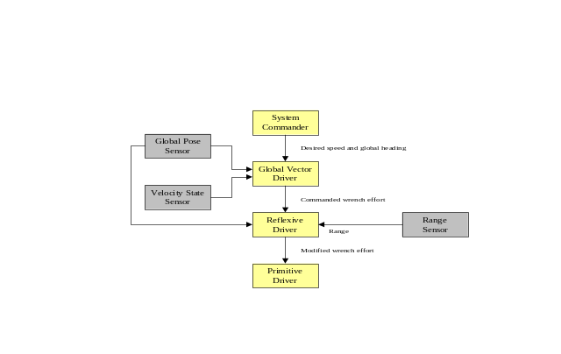
Figure 6-31 Global Vector Driving with Reflexive Driving Block Diagram
Vocabulary:
Inputs:
- Code 0407h: Set Global Vector
- Code 2407h: Query Global Vector
Outputs:
- Code 4407h: Report Global Vector
Protocol Behavior
Default

A

Figure 6-32 Global Vector Driver State Diagram
Table 6-44: Global Vector Driver Transition Table
Label | Trigger | Guard | Actions
A | Query Global Vector | None | sendReportGlobalVector
 | Set Global Vector | isComponentStatusReady | setGlobalVector
Table 6-45: Global Vector Driver Condition Table
Condition | Interpretation
isComponentStatusReady | True if Component Status Service indicates ready.
Table 6-46: Global Vector Driver Action Table
Action | Interpretation
sendReportGlobalVector | Send a Report Global Vector message.
setGlobalVector | Set the Global Vector values provided by the message.

Local Vector Driver (ID 44)
Function:
The Local Vector Driver component performs closed loop control of the desired local heading, pitch, roll and speed of a mobile platform.
Description:
The Local Vector Driver component is very similar in function to the Global Vector Driver component, the difference being that the desired heading is defined in terms of a local coordinate system as opposed to the global coordinate system. The Local Vector Driver component takes as input four pieces of information, i.e. the desired heading, pitch and roll of the platform as measured with respect to a local coordinate system and the desired speed of the platform. The desired heading angle is defined in a right hand sense about the Z axis of the local coordinate system (the Z axis points downward) where zero degrees defines a heading that is parallel to the X axis of the local coordinate system. The pitch is the angle about the Y-axis and the roll is the desired angle about the X-axis. The Local Vector Driver component also receives data from the Local Pose Sensor component and the Velocity State Sensor component. This information allows the Local Vector Driver component to perform closed loop control on both the platform’s local orientation and speed.
Figure 6-33Figure 6-33 and Figure 6-34 show two possible implementations of the Local Vector Driver interface. Figure 6-33 shows an implementation that includes the Primitive Driver interface and Figure 6-34 shows an implementation that includes both the Primitive Driver as well as the Reflexive Driver interface.
System Commander

Local Vector Driver

Desired speed and local heading

Figure 6-33 Local Vector Driver Block Diagram
.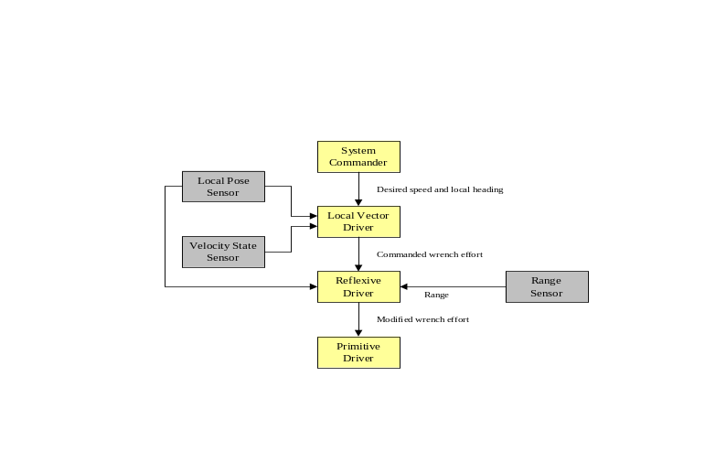
Figure 6-34 Local Vector Driver with Reflexive Driving Block Diagram
Vocabulary:
Inputs:
- Code 0408h: Set Local Vector
- Code 0427h: Insert Global Waypoint
- Code 0428h: Delete Global Waypoint
- Code 2408h: Query Local Vector
- Code 2428h: Query Current Waypoint
Outputs:
- Code 4408h: Report Local Vector
- Code 4428h: Report Current Waypoint
Protocol Behavior
Default

A

Figure 6-35 Local Vector Driver State Diagram
Table 6-47: Local Vector Driver Transition Table
Label | Trigger | Guard | Actions
A | Query Local Vector | None | sendReportLocalVector
 | Set Local Vector | isComponentStatusReady | setLocalVector
Table 6-48: Local Vector Driver Condition Table
Condition | Interpretation
isComponentStatusReady | True if Component Status Service indicates ready.
Table 6-49: Local Vector Driver Action Table
Action | Interpretation
sendReportLocalVector | Send a Report Local Vector message.
setLocalVector | Set the Local Vector values provided by the message.

Global Waypoint Driver (ID 45)
Function:
The function of the Global Waypoint Driver is to determine the desired wrench of the platform given the desired waypoint(s), travel speed, current platform pose and current velocity state.
Description:
A single waypoint or a set of waypoints is provided via the Set Global Waypoint message. A waypoint consists of the desired position and orientation of the platform. The second input consists of the desired travel speed. The travel speed is set to zero for all transitions from a Standby State to a Ready State. The desired travel speed remains unchanged unless a new Set Travel Speed Message is received. The travel speed may then be changed at any time during waypoint navigation. Once the platform reaches its final waypoint, the component must transition back to a Standby State.

The two examples shown in Figure 6-36 and Figure 6-37 are scenarios where the operator, acting as the System Commander, sets the desired waypoints and travel speed without and with reflexive driving, respectively.
System Commander

Global Waypoint Driver

Desired global waypoint(s)
Desired travel speed

Figure 6-36 Global Waypoint Driver Block Diagram
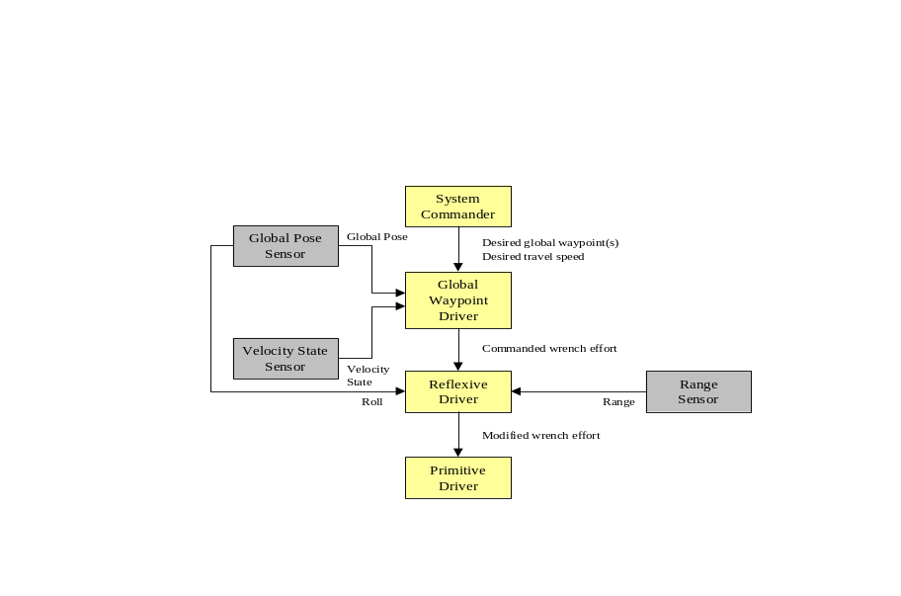
Figure 6-37 Global Waypoint Driving with Reflexive Driving Block Diagram
Vocabulary:
Inputs:
- Code 040Ah: Set Travel Speed
- Code 040Ch: Set Global Waypoint
- Code 240Ah: Query Travel Speed
- Code 240Bh: Query Waypoint Count
- Code 240Ch: Query Global Waypoint
Outputs:
- Code 440Ah: Report Travel Speed
- Code 440Bh: Report Waypoint Count
- Code 440Ch: Report Global Waypoint

Local Waypoint Driver (ID 46)
Function:
The function of the Local Waypoint Driver is to determine the desired wrench of the platform given the desired waypoint(s), travel speed, current platform pose and current velocity state.
Description:
A single waypoint or a set of waypoints is provided via the Set Local Waypoint message. A waypoint consists of the desired position and orientation of the platform and is defined in terms of a local coordinate system. The second input consists of the desired travel speed. The travel speed is set to zero for all transitions from a Standby State to a Ready State. The desired travel speed remains unchanged unless a new Set Travel Speed message is received. The travel speed may then be changed at any time during waypoint navigation. Once the platform reaches its final waypoint, the component must transition back to a Standby State.

The two examples shown in Figure 6-38 and Figure 6-39 are scenarios where the operator, acting as the System Commander, sets the desired waypoints and travel speed without and with reflexive driving, respectively.
System Commander

Local Waypoint Driver

Desired local waypoint(s)
Desired travel speed

Figure 6-38 Local Waypoint Driving Block Diagram
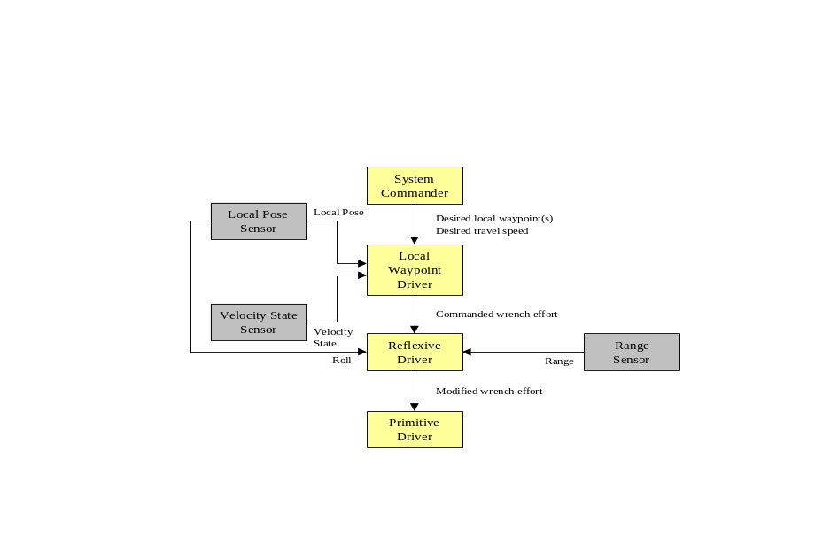
Figure 6-39 Local Waypoint Driving with Reflexive Driving Block Diagram
Vocabulary:
Inputs:
- Code 040Ah: Set Travel Speed
- Code 040Dh: Set Local Waypoint
- Code 240Ah: Query Travel Speed
- Code 240Bh: Query Waypoint Count
- Code 240Dh: Query Local Waypoint
Outputs:
- Code 440Ah: Report Travel Speed
- Code 440Bh: Report Waypoint Count
- Code 440Dh: Report Local Waypoint

Global Path Segment Driver (ID 47)
Function:
The function of the Global Path Segment Driver is to perform closed loop control of position and velocity along a path where the path is defined in a generic manner.
Description:
The Global Path Segment Driver differs from the Waypoint Drivers in that the exact path between “waypoints” is strictly defined. A path segment will be defined by specifying the three-dimensional coordinates of three points, P₀, P₁, and P₂ together with one scalar weighting value w₁. The equation of the path is defined as
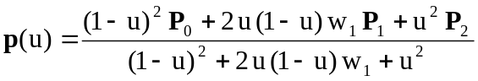,
where p represents some point on the path segment as u varies from 0 to 1. This equation defines a path segment as a second order polynomial (ellipse, parabola, or hyperbola) that lies in the plane defined by the three points P₀, P₁, and P₂. When u=0, p(0) = P₀ and when u=1, p(1) = P₂ and thus the path segment begins at point P₀ and ends at point P₂. The point P₁ is a control point that is not necessarily on the path. Figure 6-40 shows a path segment that is defined by P₀ = [1, 2, 0]^{T}, P₁ = [3, 5, 0]^{T}, P₂ = [5, 1, 0]^{T}, and w₁ = 1.5. Figure 6-41 demonstrates the effect of varying the weighting factor w₁. As can be seen in the figure, a larger value of w₁ draws the curve towards the path control point P₁.
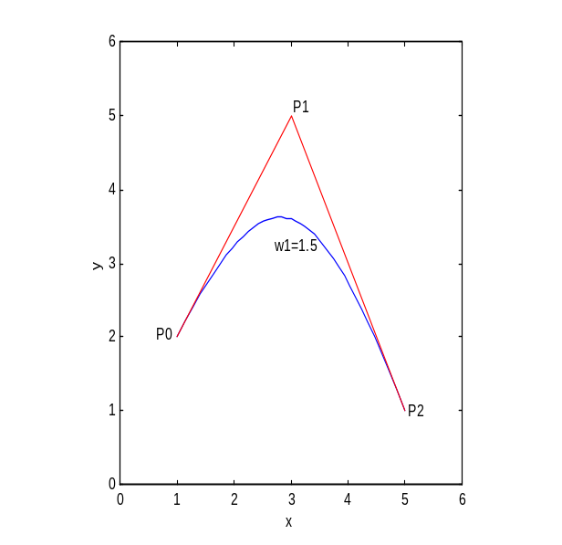
Figure 6-40 - Sample Path Segment with Control Points Shown

One feature of this representation of a path segment is that at the start of the path, the line from P₀ to P₁ will be tangent to the curve. Similarly at the end of the path, the line from P₁ to P₂ will be tangent to the curve. This feature makes it easy to define subsequent path segments so that there will be continuity at the connection point. Figure 6-42 shows the path segment shown in Figure 6-40 connected to a second path segment defined by the points P₂ = [5, 1, 0]^{T}, P₃ = [6, -1, 0]^{T}, and P₄ = [8, -1, 0]^{T} with a weighting factor of w₁ = 2. As shown in the figure, continuity of slope will occur if the line from P₁ to P₂ is collinear with the line from P₂ to P₃.
The second input consists of the desired travel speed. The travel speed is set to zero for all transitions from a Standby State to a Ready State. The desired travel speed remains unchanged unless a new Set Travel Speed message is received. The travel speed may then be changed at any time during waypoint navigation. Once the platform reaches its final waypoint, the component must transition back to a Standby State.
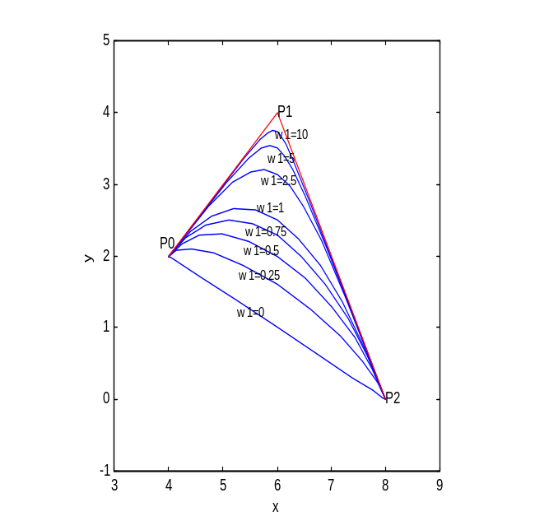
Figure 6-41 - Effect of Weighting Parameter w1 on Curve Shape
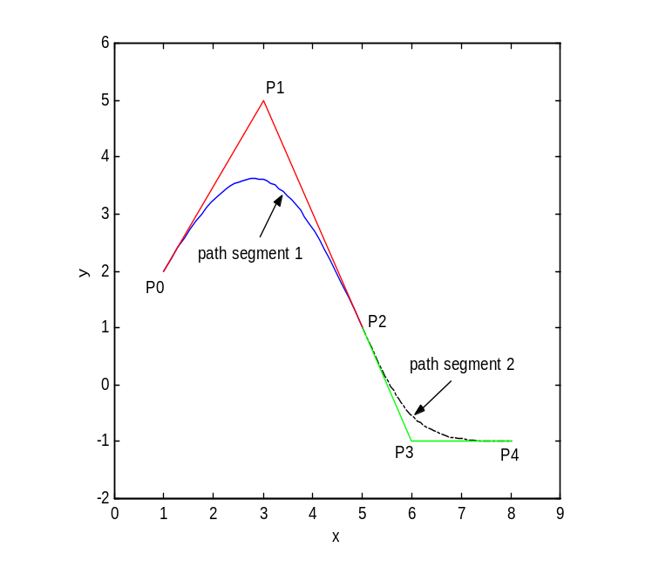
Figure 6-42 - Slope Continuity at Path Segment Connection Point
The two examples shown in Figure 6-43 and Figure 6-44 are scenarios where the operator, acting as the System Commander, sets the desired path segments and travel speed without and with reflexive driving, respectively.
System Commander

Global Path Segment Driver
Desired global path segment(s)
Desired travel speed

Figure 6-43 Path Segment Driving Block Diagram
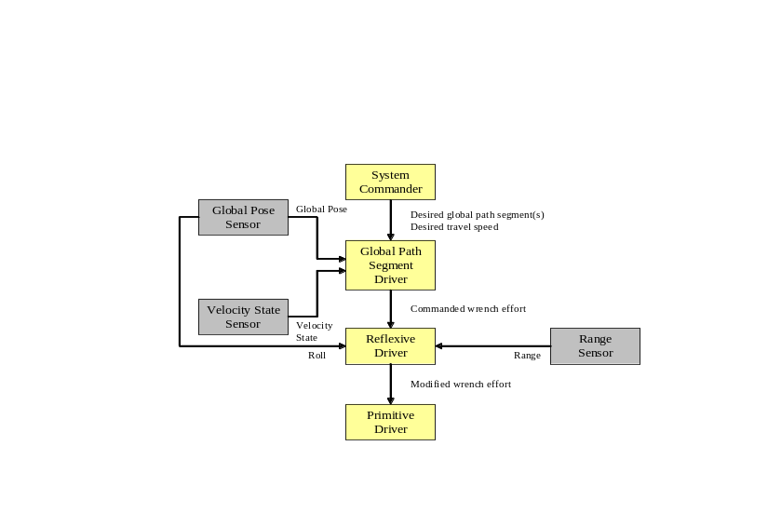
Figure 6-44 Path Segment Driving with Reflexive Driving Block Diagram
Vocabulary:
Inputs:
- Code 040Ah: Set Travel Speed
- Code 040Fh: Set Global Path Segment
- Code 240Ah: Query Travel Speed
- Code 240Eh: Query Path Segment Count
- Code 240Fh: Query Global Path Segment
Outputs:
- Code 440Ah: Report Travel Speed
- Code 440Eh: Report Path Segment Count
- Code 440Fh: Report Global Path Segment

Local Path Segment Driver (ID 48)
Function:
The function of the Local Path Segment Driver is to perform closed loop control of position and velocity along a path where the path is defined in a generic manner.
Description:
A three-dimensional path segment will be defined by specifying the coordinates of three points, P₀, P₁, and P₂ together with one scalar weighting value w₁. The equation of the path is defined as
,
where p represents some point on the path segment as u varies from 0 to 1. A more complete discussion of this path segment representation is presented in the description of the Global Path Segment Driver component (See Section ).
The two examples shown in Figure 6-45 and Figure 6-46 are scenarios where the operator, acting as the System Commander, sets the desired path segments and travel speed without and with reflexive driving, respectively.
System Commander

Local Path Segment Driver
Desired local path segment(s)
Desired travel speed

Figure 6-45 Local Path Segment Driving Block Diagram

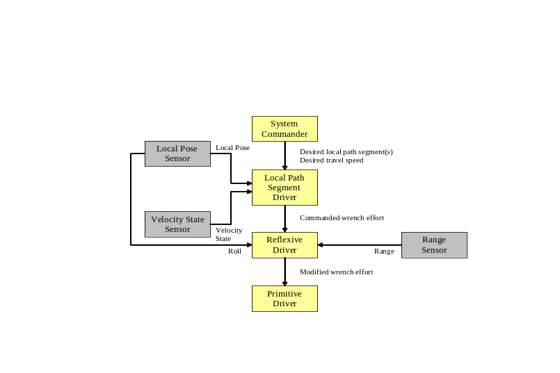
Figure 6-46 Local Path Segment Driving with Reflexive Driving Block Diagram
Vocabulary:
Inputs:
- Code 040Ah: Set Travel Speed
- Code 0410h: Set Local Path Segment
- Code 240Ah: Query Travel Speed
- Code 240Eh: Query Path Segment Count
- Code 2410h: Query Local Path Segment
Outputs:
- Code 440Ah: Report Travel Speed
- Code 440Eh: Report Path Segment Count
- Code 4410h: Report Local Path Segment

Trim Tab Control (ID 63)
Function:
The function of this component is to report trim tab identificatoins, set and report trim tab efforts and positions.
Description:
To control and monitor trim tab(s) on a platofrm, a controller will initially find out the identification(s) of the trim tab(s) via Query Trim Tab Identifications. The controller can then use the trim tab IDs to query and set the corresponding trim tabs’ efforts and positions.
Vocabulary:
Inputs:
- Code 0421h: Set Trim Tab Position
- Code 0422h: Set Trim Tab Effort
- Code 2420h: Query Trim Tab Identifications
- Code 2421h: Query Trim Tab Positions
- Code 2422h: Query Trim Tab Effort
Outputs:
- Code 4420h: Report Trim Tab Identifications
- Code 4421h: Report Trim Tab Positions
- Code 4422h: Report Trim Tab Effort
Protocol Behavior
Default

A

Figure 6-47 Trim Tab Control State Diagram
Table 6-50: Trim Tab Control Transition Table
Label | Trigger | Guard | Actions
A | Query Trim Tab Identifications | None | sendReportTrimTabIdentifications
 | Query Trim Tab Position | isComponentStatusReady | sendReportTrimTabPosition
 | Query Trim Tab Effort | isComponentStatusReady | sendReportTrimTabEffort
 | Set Trim Tab Position | isComponentStatusReady AND requesterInControl | setTrimTabPosition
 | Set Trim Tab Effort | isComponentStatusReady AND requesterInControl | setTrimTabEffort
Table 6-51: Trim Tab Control Condition Table
Condition | Interpretation
isComponentStatusReady | True if Component Status Service indicates ready.
requesterInControl | True if Component Control Service indicates requester is in control.
Table 6-52: Trim Tab Control Action Table
Action | Interpretation
sendReportTrimTabIdentifications | Send a Report Trim Tab Identifications message.
sendReportTrimTabPosition | Send a Report Trim Tab Position message.
sendReportTrimTabEffort | Send a Report Trim Tab Effort message.
setTrimTabPosition | Set the trim tab position to the value received.
setTrimTabEffort | Set the trim tab effort to the value received.

Power Supply Status (ID 64)
Function:
This component reports power supply identifications and status.
Description:
To monitor power supplies on a platform, a controller will initially find out the identifications of the power supplies via Query Power Supply Identifications. The controller can then use the power supply IDs to query the corresponding power supplies’ status.
Vocabulary:
Inputs:
- Code 241Ah: Query Power Supply Identifications
- Code 241Bh: Query Power Supply Status
Outputs:
- Code 441Ah: Report Power Supply Identifications
- Code 441Bh: Report Power Supply Status
Protocol Behavior
Default

A

Figure 6-48 Power Supply Status State Diagram
Table 6-53: Power Supply Status Transition Table
Label | Trigger | Guard | Actions
A | Query Power Supply Identifications | None | sendReportPowerSupplyIdentifications
 | Query Power Supply Status | isComponentStatusReady | sendReportPowerSupplyStatus
Table 6-54: Power Supply Status Condition Table
Condition | Interpretation
isComponentStatusReady | True if Component Status Service indicates ready.
Table 6-55: Power Supply Status Action Table
Action | Interpretation
sendReportPowerSupplyIdentifications | Send a Report Power Supply Identifications message.
sendReportPowerSupplyStatus | Send a Report Power Supply Status message.

Generator Status (ID 66)
Function:
This component reports generator identifications and status.
Description:
To monitor generator(s) on a platform, a controller will initially find out the identifications of the generators via Query Generator Identifications. The controller can then use the generator IDs to query the corresponding generators’ status.
Vocabulary:
Inputs:
- Code 242Bh: Query Generator Identifications
- Code 242Ch: Query Generator Status
Outputs:
- Code 442Bh: Report Generator Identifications
- Code 442Ch: Report Generator Status
Protocol Behavior
Default

A

Figure 6-49 Generator Status State Diagram
Table 6-56: Generator Status Transition Table
Label | Trigger | Guard | Actions
A | Query Generator Identifications | None | sendReportGeneratorIdentifications
 | Query Generator Status | isComponentStatusReady | sendReportGeneratorStatus
Table 6-57: Generator Status Condition Table
Condition | Interpretation
isComponentStatusReady | True if component status indicates ready.
Table 6-58: Generator Status Action Table
Action | Interpretation
sendReportGeneratorIdentifications | Send a Report Generator Identifications message.
sendReportGeneratorStatus | Send a Report Generator Status message.

Bucket Control (ID 68)
Function:
This component reports bucket identifications, sets and reports bucket positions.
Description:
A water jet driven boat has a bucket for controlling forward/reverse thrust. This component is to control and monitor bucket(s) on the platform. A controller will initially find out the identifications of the buckets via Query Bucket Identifications. The controller can then use the bucket IDs to query and set the corresponding buckets’ positions.
Vocabulary:
Inputs:
- Code 0430h: Set Bucket Position
- Code 242Fh: Query Bucket Identifications
- Code 2430h: Query Bucket Position
Outputs:
- Code 442Fh: Report Bucket Identifications
- Code 4430h: Report Bucket Position
Protocol Behavior
Default

A

Figure 6-50 Bucket Control State Diagram
Table 6-59: Bucket Control Transition Table
Label | Trigger | Guard | Actions
A | Set Bucket Position | isComponentStatusReady AND requesterInControl | setBucketPosition
 | Query Bucket Identifications | None | sendReportBucketIdentifications
 | Query Bucket Position | isComponentStatusReady | sendReportBucketPosition
Table 6-60: Bucket Control Condition Table
Condition | Interpretation
isComponentStatusReady | True if component status indicates ready.
requesterInControl | True if Component Control Service indicates requester is in control.
Table 6-61: Bucket Control Action Table
Action | Interpretation
setBucketPosition | Set the bucket position to value provided.
sendReportBucketIdentifications | Send a Report Bucket Identifications message.
sendReportBucketPosition | Send a Report Bucket Position message.

Bow Thruster Control (ID 69)
Function:
This component reports bow thruster identifications, sets and reports the thruster efforts.
Description:
A bow thruster is a propulsion device built into, or mounted to, the bow of a ship or boat to enhance its maneuverability. Bow thrusters make docking easier, since they allow the Captain to turn the vessel to port or starboard without using the main propulsion mechanism which requires some forward motion for turning. From old boating practices, port is left and starboard is right as perceived by a person on board the ship and facing the bow (front).
This component is to control and monitor bow thruster(s) on a platform, a controller will initially find out the identifications of the thrusters via Query Bow Thruster Identifications. The controller can then use the thruster IDs to query and set the corresponding thrusters’ efforts.
Vocabulary:
Inputs:
- Code 0432h: Set Bow Thruster Effort
- Code 2432h: Query Bow Thruster Identifications
- Code 2432h: Query Bow Thruster Effort
Outputs:
- Code 4431h: Report Bow Thruster Identifications
- Code 4432h: Report Bow Thruster Effort
Protocol Behavior
Default

A

Figure 6-51 Bow Thruster Control State Diagram
Table 6-62: Bow Thruster Control Transition Table
Label | Trigger | Guard | Actions
A | Set Bow Thruster Effort | isComponentStatusReady AND requesterInControl | setBowThrusterEffort
 | Query Bow Thruster Identifications | None | sendReportBowThrusterIdentifications
 | Query Bow Thruster Effort | isComponentStatusReady | setBowThrusterEffort
Table 6-63: Bow Thruster Control Condition Table
Condition | Interpretation
isComponentStatusReady | True if component status indicates ready.
requesterInControl | True if Component Control Service indicates requester is in control.
Table 6-64: Bow Thruster Control Action Table
Action | Interpretation
setBowThrusterEffort | Set the bow thruster efforts to values provided.
sendReportBowThrusterIdentifications | Send a Report Bow Thruster Identifications message.
sendReportBowThrusterEffort | Send a Report Bow Thruster Effort message.

Primitive Hydraulics (ID 73)
Function:
This component reports common status data of one or more hydraulic systems.
Descriptions:
The Primitive Hydraulic component provides typical status of hydraulic systems.
Six data elements are in the Report Hydraulic Data message. They are Oil Compensator Level, Oil Compensator Temp, Oil Level, Oil Pressure, Oil Return Temp, Hydraulic Pressure, and Hydraulic Temperature.
Vocabulary:
Inputs:
- Code 2433h: Query Hydraulic Data
- Code 2434h: Query Hydraulic System Identifications
Outputs:
- Code 4433h: Report Hydraulic Data
- Code 4434h: Report Hydraulic System Identifications
Protocol Behavior
Default

A

Figure 6-52 Primitive Hydraulics State Diagram
Table 6-65: Primitive Hydraulics Transition Table
Label | Trigger | Guard | Actions
A | Query Hydraulic Data | isComponentStatusReady | sendReportHydraulicData
 | Query Hydraulic System Identifications | None | sendReportHydraulicSystemIndentification
Table 6-66: Primitive Hydraulics Condition Table
Condition | Interpretation
isComponentStatusReady | True if component status indicates ready.
Table 6-67: Primitive Hydraulics Action Table
Action | Interpretation
sendReportHydraulicData | Send a Report Hydraulic Data message.
sendReportHydraulicSystemIndentifications | Send a Report Hydraulic System Indentifications message.

Device Power Manager (ID 74)
Function:
This component provides all devices’ identification info, allows a controller to set each device’s power to on, off or reboot, and reports devices’ power status.
Description:
The Device Power Management component provides a message set that allows every component to easily control the power settings of any unique set of devices. Initially, a controller would find out the name and the identifier of all devices or the ones it interested via the Query Device Identifications and Report Device Identifications messages. The controller can then use the device IDs to control the devices’ power status.
Vocabulary:
Inputs:
- Code 0415h: Set Device Power
- Code 2415h: Query Device Power Status
- Code 2416h: Query Device Identifications
Outputs:
- Code 4415h: Report Device Power Status
- Code 4416h: Report Device Identifications
Protocol Behavior
Default

A

Figure 6-53 Device Power Manager State Diagram
Table 6-68: Device Power Manager Transition Table
Label | Trigger | Guard | Actions
A | Query Device Power Status | isComponentStatusReady | sendReportDevicePowerStatus
 | Query Device Configuration | None | sendReportDeviceConfiguration
 | Set Device Power | isComponentStatusReady AND requesterInControl | setDevicePower
Table 6-69: Device Power Manager Condition Table
Condition | Interpretation
isComponentStatusReady | True if component status indicates ready.
requesterInControl | True if Component Control Service indicates requester is in control.
Table 6-70: Device Power Manager Action Table
Action | Interpretation
sendReportDevicePowerStatus | Send a Report Device Power Status message.
sendReportDeviceConfiguration | Send a Report Device Configuration message.
setDevicePower | Set the Device Power to the value given.

Acceleration State Sensor (ID 76)
Function:
This component reports the acceleration state of the unmanned platform.
Description:
The Acceleration State Sensor reports the acceleration state that is the first derivative (the rate of change) of the velocity state reported by the Velocity State Sensor. Please refer to the description on Velocity State Sensor for coordinate details.
Vocabulary:
Inputs:
Code 2417h: Query Acceleration State
Outputs:
Code 4417h: Report Acceleration State
Protocol Behavior
Default

A

Figure 6-54 Acceleration State Sensor State Diagram
Table 6-71: Acceleration State Sensor Transition Table
Label | Trigger | Guard | Actions
A | Query Acceleration State | isComponentStatusReady | sendReportAccelerationState
Table 6-72: Acceleration State Sensor Condition Table
Condition | Interpretation
isComponentStatusReady | True if component status indicates ready.
Table 6-73: Acceleration State Sensor Action Table
Action | Interpretation
sendReportAccelerationState | Send a Report Acceleration State message.

Manipulator Components
This section provides a brief explanation of several components that can be used for command and control a manipulator arm. The components focus on a serial manipulator comprised of any number of prismatic and revolute joints. The components are grouped according to function into the following categories:
Low Level Manipulator Control Components – The one component in this category allows for low-level command of the manipulator joint actuation efforts. This is an open-loop command that could be used in a simple tele-operation scenario. The component in this category is listed as follows:
Primitive Manipulator Component
Manipulator Sensor Components – These components, when queried, return instantaneous sensor data. Three components are defined that return respectively joint positions, joint velocities, and joint torques or forces. The components in this category are listed as follows:
Manipulator Joint Position Sensor Component
Manipulator Joint Velocity Sensor Component
Manipulator Joint Force/Torque Sensor Component
Low Level Position and Velocity Driver Components – These components take as inputs the desired joint positions, the desired joint velocities, the desired end-effector pose, or the desired end-effector velocity state. Closed-loop control is implied. No path information is specified. The components in this category are listed as follows:
Manipulator Joint Positions Driver Component
Manipulator End-Effector Pose Driver Component
Manipulator Joint Velocities Driver Component
Manipulator End-Effector Velocity State Driver Component
Mid Level Position and Velocity Driver Components – Two components are grouped here under this heading. The first takes as input the goal values for each joint parameter at several time values together with motion constraints, i.e. maximum joint velocity, maximum acceleration, and maximum deceleration. The second takes as input a series of end-effector poses at specified time values. Closed-loop control is implied. The components in this category are listed as follows:
Manipulator Joint Move Driver Component
Manipulator End-Effector Discrete Pose Driver Component

Definition of Coordinate Systems
Global Coordinate System
Points that are defined in this coordinate system are defined in units of longitude, latitude, and elevation. The X-axis is defined as pointing North and the Z axis points downward.
Vehicle Coordinate System
This coordinate system is defined as attached to the vehicle frame. The X-axis points in the forward direction and the Z-axis points downward. The Y-axis is defined so as to have a right-handed coordinate system, i.e. i × j = k where j, k, and i are unit vectors along the X, Y, and Z coordinate axes.
Manipulator Base Coordinate System
In most cases, this coordinate system is attached to the vehicle base just as the vehicle coordinate system is. The origin is located at the intersection of the line along the first joint axis, S₁, and the line along the first link, a₁₂. The Z axis is along S₁ and the direction of the X-axis is user defined, but fixed with respect to the vehicle frame. Since the manipulator base coordinate system and the vehicle coordinate system are both attached to the vehicle base, the transformation matrix that describes the relative position and orientation of these two coordinate systems will be constant (in some cases a manipulator may be attached to the end of another manipulator and this would not be the case).
End-Effector Coordinate System
This coordinate system is attached to the last link of the serial manipulator. The origin is located at the point that is a distance S_{n} (S₆ for a six axis manipulator) along the last joint axis vector (S₆ for a six axis manipulator) from the intersection of the lines along the last joint axis and the preceding link axis (S₆ and a₅₆ for a six axis manipulator). The Z-axis is along the S_{n} vector. The direction of the X-axis is user defined, but of course must be perpendicular to the Z-axis. The Y-axis is defined by the right-hand rule.
Note: The distance S_{n} is returned by the Primitive Manipulator Component via the Report Manipulator Specifications Message.

Primitive Manipulator (ID 49)

Function:
This component is concerned only with the remote operation (open-loop control) of a single manipulator system. The manipulator may or may not have joint measurement sensors that would provide joint position and joint velocity information. Without joint measurement sensors, the operator can only send joint motion efforts as commands to the manipulator. This component does not use any joint angle or velocity feedback from the manipulator. It only receives the desired percentage of maximum joint effort for each joint as an input.

- Description:
This component is the low level interface to a manipulator arm and is in many respects similar to the Primitive Driver component for mobility of the platform. When queried, the component will reply with a description of the manipulator’s specification parameters, axes range of motion, and axes velocity limits. The notations used to describe these data are documented in many popular text books on robotics and were previously presented in Part 2, Section 2.5. The mechanism specification parameters as reported by the Report Manipulator Specifications Message consist of the number of joints, the type of each joint (either revolute or prismatic), the link description parameters for each link (link length and twist angle as shown in Part 2, Figure 2.2), the constant joint parameter value (offset for a revolute joint (see Part 2, Figure 2.3), and joint angle for a prismatic joint (see Part 2, Figure 2.4)). The minimum and maximum allowable value for each joint and the maximum velocity for each joint follow this information. Motion of the arm is accomplished via the Set Joint Effort message (See Figure 6-55). In this message, each actuator is commanded to move with a percentage of maximum effort.
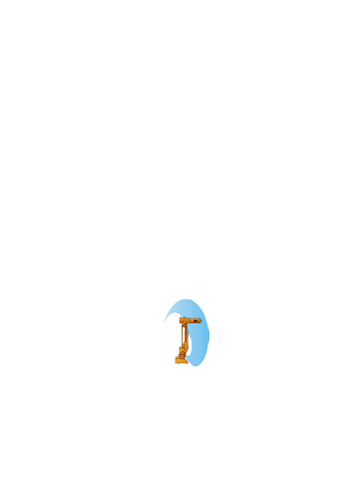
Figure 6-55 Joint Effort Provides Basic Manipulator Mobility
Vocabulary:
Inputs
- Code 0601h: Set Joint Efforts
- Code 2600h: Query Manipulator Specifications
- Code 2601h: Query Joint Efforts
- Code 2606h: Query Commanded Joint Positions
Outputs:
- Code 4600h: Report Manipulator Specifications
- Code 4601h: Report Joint Efforts
- Code 4606h: Report Commanded Joint Positions

Manipulator Joint Position Sensor Component (ID 51)
Function:
The Function of the Joint Position Sensor Component is to report the values of manipulator joint parameters when queried.

- Description:
The Report Joint Positions message provides the instantaneous joint positions. The positions are given in degrees for revolute and in meters for prismatic joints. The component is depicted in Figure 6-56.
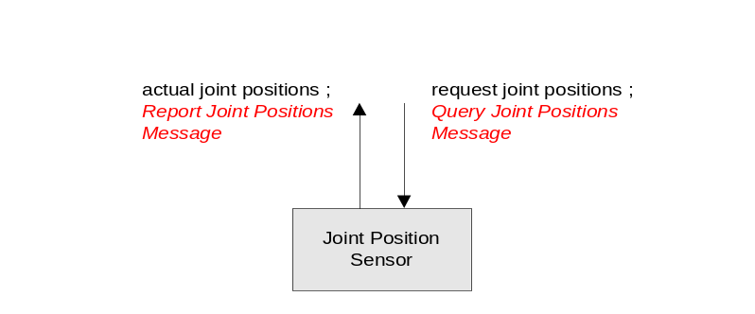
Figure 6-56 Joint Position Sensor Component
Vocabulary:
Inputs
- Code 2602h: Query Joint Positions
- Code 2606h: Query Commanded Joint Positions
Outputs:
- Code 4602h: Report Joint Positions
- Code 4606h: Report Commanded Joint Positions

Manipulator Joint Velocity Sensor Component (ID 52)
Function:
The Function of the Joint Velocity Sensor is to report the values of instantaneous joint velocities when queried.

- Description:
The Report Joint Velocities message provides the instantaneous joint velocities. The velocities are given in radians/sec for revolute and in meters/sec for prismatic joints. The component is depicted in Figure 6-57.
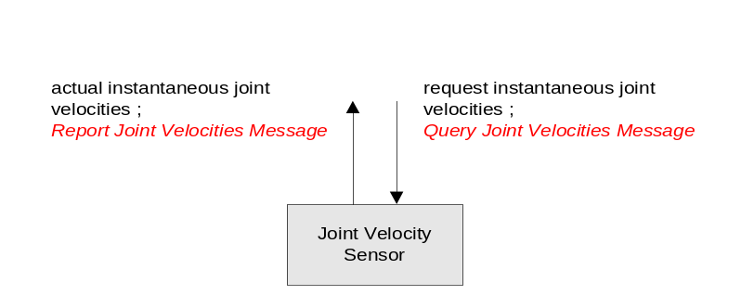
Figure 6-57 Joint Velocity Sensor Component
Vocabulary:
Inputs
- Code 2603h: Query Joint Velocities
- Code 2606h: Query Commanded Joint Positions
Outputs:
- Code 4603h: Report Joint Velocities
- Code 4606h: Report Commanded Joint Positions

Manipulator Joint Force/Torque Sensor Component (ID 53)
Function:
The Function of the Joint Force/Torque Sensor is to report the values of instantaneous torques (for revolute joints) and forces (for prismatic joints) that are applied at the individual joints of the manipulator kinematic model when queried.

- Description:
The Joint Force/Torque Sensor component provides the instantaneous joint forces or torques that are acting on each joint of the manipulator kinematic model. Forces are returned for prismatic joints in units of Newton’s. Torques is returned for revolute joints in units of Newton-meters.
Vocabulary:
Inputs
- Code 2605h: Query Joint Force/Torque
- Code 2606h: Query Commanded Joint Positions
Outputs:
- Code 4605h: Report Joint Force/Torque
- Code 4606h: Report Commanded Joint Positions

Manipulator Joint Positions Driver Component (ID 54)
Function:
The Function of the Joint Positions Driver is to perform closed-loop joint position control.

Description:
The inputs allow a client to (1) set the desired joint values and (2) query what the values of the commanded joint angles are. The output is a report in reply to the query which lists the commanded joint angles. Multiple sets of joint values can be communicated in one ‘Set Joint Positions’ message.

Vocabulary:
Inputs
- Code 0602h: Set Joint Positions
- Code 2606h: Query Commanded Joint Positions
Outputs:
- Code 4606h: Report Commanded Joint Positions

Manipulator End-Effector Pose Driver Component (ID 55)
Function:
The Function of the Manipulator End-Effector Pose Driver is to perform closed-loop position and orientation control of the end-effector.
Associated Messages:
- Set Tool Point
- Set End-Effector Pose
- Query Tool Point
- Report Manipulator Specifications
- Report Joint Efforts
- Report Joint Positions
- Set Joint Effort
- Report Tool Point
Description:
This component performs closed-loop position and orientation control of the end-effector. The input is the desired position and orientation of the end-effector specified in the vehicle coordinate system, the current joint angles, and the data from the manipulator specification report. The output is the joint effort level that is sent to the Primitive Manipulator component. It should be noted that in most implementations that this component and the Primitive Manipulator component would be embedded in the same node that will facilitate the control process. The component is depicted in Figure 6-59.
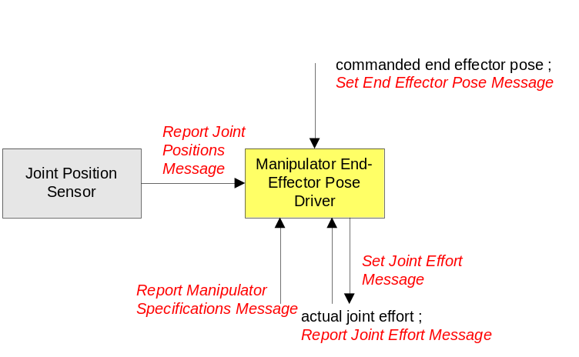
Figure 6-59 Manipulator End-Effector Pose Driver
Vocabulary:
Inputs
- Code 2606h: Query Commanded Joint Positions
Outputs:
- Code 4606h: Report Commanded Joint Positions

Manipulator Joint Velocities Driver Component (ID 56)
Function:
The Function of the Joint Velocities Driver is to perform closed-loop joint velocity control.
Associated Messages:
- Set Joint Velocities
- Report Manipulator Specifications
- Report Joint Effort
- Report Joint Velocities
- Set Joint Effort
Description:
The input consists of the desired instantaneous joint velocities, the current joint velocities, and the data from the manipulator specification report. The output is the joint effort level that is sent to the Primitive Manipulator component. It should be noted that in most implementations that this component and the Primitive Manipulator component will be embedded in the same node which will facilitate the control process. The component is depicted in Figure 6-60.
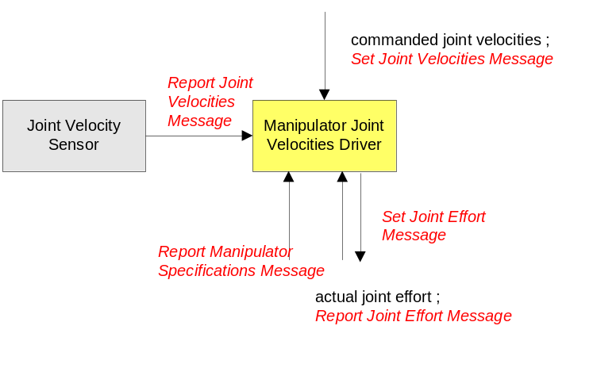
Figure 6-60 Manipulator Joint Velocities Driver
Vocabulary:
Inputs
- Code 2606h: Query Commanded Joint Positions
Outputs:
- Code 4606h: Report Commanded Joint Positions

Manipulator End-Effector Velocity State Driver Component (ID 57)
Function:
The Function of the Manipulator End-Effector Velocity State Driver is to perform closed-loop velocity control of the end effector.
Associated Messages:
- Set End-Effector Velocity State
- Report Manipulator Specifications
- Report Joint Effort
- Report Joint Positions
- Report Joint Velocities
- Set Joint Effort
Description:
The input is the desired end-effector velocity state, specified in the vehicle coordinate system or the end-effector coordinate system, the current joint positions and joint velocities, and the data from the manipulator specifications report. The output is the joint effort level that is sent to the Primitive Manipulator component. It should be noted that in most implementations that this component and the Primitive Manipulator component would be embedded in the same node that will facilitate the control process. Figure 6-61 depicts this component.
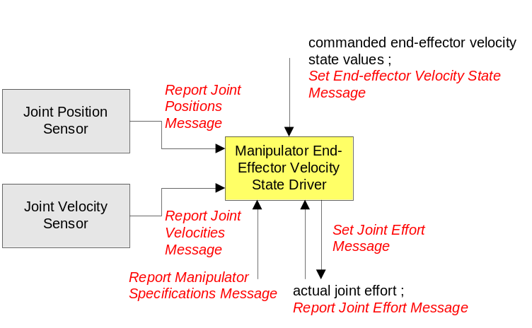
Figure 6-61 Manipulator End-Effector Velocity State Driver Component
Vocabulary:
Inputs
- Code 2606h: Query Commanded Joint Positions
Outputs:
- Code 4606h: Report Commanded Joint Positions

Manipulator Joint Move Driver Component (ID 58) (DEPRECATE IN v4.0)
Function:
The function of the Manipulator Joint Move Driver is to perform closed-loop joint level control of the manipulator where motion parameters for each joint are specified. The specified motion parameters are the desired values, maximum velocity, maximum acceleration, and maximum deceleration for each joint.
Associated Messages:
- Set Joint Motion
- Report Manipulator Specifications
- Report Joint Effort
- Report Joint Positions
- Report Joint Velocities
- Set Joint Effort
Description:
The inputs are the desired joint values at specified time values together with data to define a trapezoidal velocity profile, i.e. the maximum joint velocity, maximum joint acceleration, and maximum joint deceleration. No explicit path is defined, only the values of the joint angles at distinct times. The time values are measured in units of seconds and are relative to the time that the movement to the first joint angle set is started.

Additional inputs are the current joint values, joint velocities, and the data from the Report Manipulator Specifications message. The output is the joint effort level that is sent to the Primitive Manipulator component. It should be noted that in most implementations that this component and the Primitive Manipulator component will be embedded in the same node which will facilitate the control process. The component is depicted in Figure 6-62.
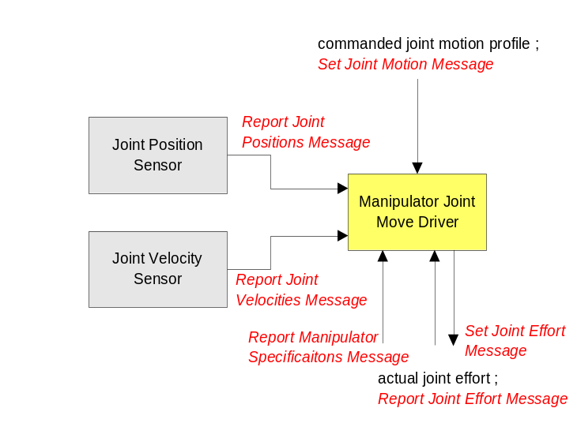
Figure 6-62 Manipulator Joint Move Driver Component
Vocabulary:
Inputs
- Code 2606h: Query Commanded Joint Positions
Outputs:
- Code 4606h: Report Commanded Joint Positions

Manipulator End-Effector Discrete Pose Driver Component (ID 59)
Function:
The function of the Manipulator End-Effector Discrete Pose Driver is to perform closed-loop control of the end-effector pose through a series of specified positions and orientations.
Associated Messages:
- Set End-Effector Path Motion
- Report Manipulator Specifications
- Report Joint Effort
- Report Joint Positions
- Report Joint Velocities
- Set Joint Effort
Description:
This component performs closed-loop control of the end-effector pose as measured with respect to the vehicle coordinate system. The inputs are a path motion description (discrete end-effector position and orientation at time t measured in the vehicle coordinate system which is defined by a point and a quaternion at time t), the current joint values, the current joint velocities, and the data from the Report Manipulator Specifications message. The output is the joint effort level that is sent to the Primitive Manipulator component. It should be noted that in most implementations that this component and the Primitive Manipulator component would be embedded in the same node that will facilitate the control process. The component is depicted in Figure 6-63 in the vehicle coordinate system.
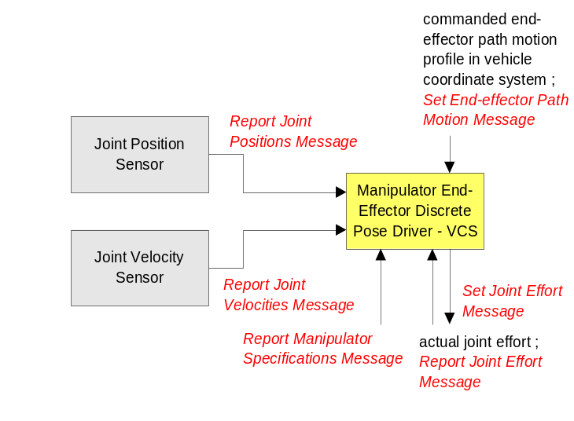
Figure 6-63 Manipulator End-Effector Discrete Pose Driver Component
Vocabulary:
Inputs
- Code 2606h: Query Commanded Joint Positions
Outputs:
- Code 4606h: Report Commanded Joint Positions

Environment Sensing and Modeling Components

Visual Sensor (ID 37)
Function:
The Visual Sensor component has the responsibility of controlling the camera(s) of a subsystem.
Description:
Each camera has an associated coordinate frame. The Z-axis of the coordinate frame is positive along the centerline of the camera lens, pointing toward the field of view. From an observer looking through the camera, the X-axis is positive to the right and is in the horizontal plane of the image sensor. The Y-axis completes the right-handed orthogonal coordinate frame.
The visual component has the capability to control the positioning and orientation of a fully articulated camera mounting. The visual component also provides the mechanisms to determine and set the imagery format, camera settings, and audio (if supported).

Range Sensor (ID 50)
Function:
This component reports range data to requesting components. The range data is measured relative to the platform coordinate system at the time reported.
Description:
The Range Sensor component provides information from proximity sensors for the purpose of object detection. The Range Sensor shall output the locations of detected objects with a certain measure of accuracy. The Range Sensor may consist of a single range sensor or multiple sensors. With this most primitive sensor, raw data from the sensors are processed and formatted into standard, semi-raw data and returned when requested.

World Model Vector Knowledge Store (ID 61)
Function:
The function of the World Model Vector Knowledge Store (WMVKS) component is to provide a central repository for system-, subsystem-, node-, and/or component-level vector-formatted geospatial data.
Associated Messages:
- Create Vector Knowledge Store Objects
- Set Vector Knowledge Store Feature Class Metadata
- Delete Vector Knowledge Store Objects
- Query Vector Knowledge Store Objects
- Query Vector Knowledge Store Feature Class Metadata
- Query Vector Knowledge Store Bounds
- Terminate Vector Knowledge Store Data Transfer
- Report Vector Knowledge Store Object(s) Creation
- Report Vector Knowledge Store Feature Class Metadata
- Report Vector Knowledge Store Objects
- Report Vector Knowledge Store Bounds
- Report Vector Knowledge Store Data Transfer Termination
Description:
Storing and sharing of vector-formatted geospatial data is supported by the World Model Vector Knowledge Store. The primary benefit of this world modeling method is that vector data typically require significantly less bandwidth to transmit as compared to raster data.
For the vector knowledge store, objects are represented as points, lines and polylines, and polygons. Figure 6-64 shows the format of these vector objects. Polylines and polygons may consist of up to 65535 vertices. Rather than assigning the points that make up these objects Cartesian coordinates with respect to an arbitrarily chosen datum, all points are expressed as points of latitude and longitude (WGS84).
The vector objects on the right side of Figure 6-64 have a region buffer parameter. The region buffer is defined as an offset distance in meters that establishes a radial region around each vector object vertex and connects the radial regions of two or more radial regions by drawing lines at their tangents. The area within these radial regions and tangent lines are considered to be within the vector object’s buffer zone. This buffer feature allows a region to be established in proximity to vector objects. For example, United States Geological Survey (USGS) digital line graph (DLG) road data is presented in vector form representing the center-line of such roads. It may be useful to search for objects within an area along a particular route defined in the digital line graph data. For simple cases, it may be possible to generate a polygonal representation of the area around the road. Establishing this polygon will require transmitting the coordinates of each of its vertices. As the problem scales up, this method becomes very inefficient. A better solution to this problem would be to determine the route using the DLG data and assign a region buffer to each line segment.

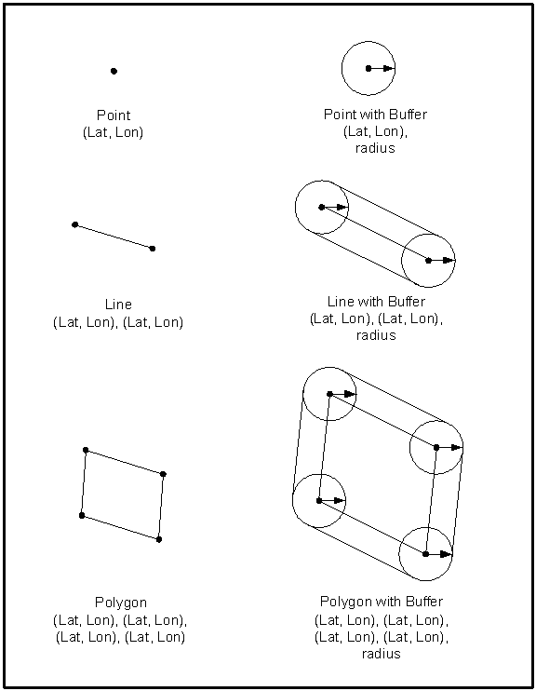
Figure 6-64 Vector Objects

Wind Sensor (ID 70)
Function:
This component provides common wind data.

Description:
Wind Sensor reports relative and true wind direction as well as relative and true wind speed. Relative wind direction is the wind direction relative to the vehicle’s actual course (In Report Global Pose, we often use its heading as the vehicle’s course. Such usage is OK for an UGV as its heading typically aligns with its course. However, assuming a vehicle’s heading is also the vehicle’s course is faulty, as UAVs, USVs, and UUVs can run in one direction while having their physical body face or point at another direction). Relative wind speed is the wind speed relative to the vehicle’s speed over ground.
Vocabulary
Inputs:
- Code 2809h: Query Wind Sensor Data
Outputs:
- Code 4809h: Report Wind Sensor Data
Protocol Behavior
Default

A

Figure 6-65 Wind Sensor State Diagram
Table 6-74: Wind Sensor Transition Table
Label | Trigger | Guard | Actions
A | Query Wind Sensor Data | isComponentStatusReady | sendReportWindSensorData
Table 6-75: Wind Sensor Condition Table
Condition | Interpretation
isComponentStatusReady | True if Component Status Service indicates ready.
Table 6-76: Wind Sensor Action Table
Action | Interpretation
sendReportWindSensorData | Send a Report Wind Sensor Data message.

Water Sensor (ID 71)
Function:
This component reports data about a water body where the sensor operates.
Description:
The water sensor provides water depth, chemical and physical properties of the water the sensor senses.
Vocabulary
Inputs:
- Code 280Ah: Query Water Chemical Properties
- Code 280Bh: Query Water Physical Properties
- Code 280Ch: Query Water Depth
Outputs:
- Code 480Ah: Report Water Chemical Properties
- Code 480Bh: Report Water Physical Properties
- Code 480Ch: Report Water Depth
Protocol Behavior
Default

A

Figure 6-66 Water Sensor State Diagram
Table 6-77: Water Sensor Transition Table
Label | Trigger | Guard | Actions
A | Query Water Chemical Properties | isComponentStatusReady | sendReportWaterChemicalProperties
 | Query Water Physical Properties | isComponentStatusReady | sendReportWaterPhysicalProperties
 | Query Water Depth | isComponentStatusReady | sendReportWaterDepth
Table 6-78: Water Sensor Condition Table
Condition | Interpretation
isComponentStatusReady | True if Component Status Service indicates ready.
Table 6-79: Water Sensor Action Table
Action | Interpretation
sendReportWaterChemicalProperties | Send a Report Water Chemical Properties message.
sendReportWaterPhysicalProperties | Send a Report Water Physical Properties message.
sendReportWaterDepth | Send a Report Water Depth message.

Atmoshpere Sensor (ID 75)
Function:
This component reports atmospheric data.
Description:
The Atmosphere Sensor provides atmospheric data in humidity, temperature, and atmospheric pressure.
Vocabulary:
Inputs:
- Code 2808h: Query Atmosphere Data
Outputs:
- Code 4808h: Report Atmosphere Data
Protocol Behavior
Default

A

Figure 6-67 Atmosphere Sensor State Diagram
Table 6-80: Atmosphere Sensor Transition Table
Label | Trigger | Guard | Actions
A | Query Atmosphere Data | isComponentStatusReady | sendReportAtmosphereData
Table 6-81: Atmosphere Sensor Condition Table
Condition | Interpretation
isComponentStatusReady | True if Component Status Service indicates ready.
Table 6-82: Atmosphere Sensor Action Table
Action | Interpretation
sendReportAtmosphereData | Send a Report Atmosphere Data message.

Planning Components
This section provides a brief explanation of components that can be used for mission coordination and execution. The components and their message sets provide detailed knowledge of the machine’s capabilities, the mission goals and objectives, and a mechanism for conveying the plan to the primitives within the machine. The Mission Planning, Coordination and Execution process for JAUS systems is graphically depicted below where the process, or pieces of the process, can be located and/or duplicated anywhere in the system. The process allows for the generation and execution of complex mission plans made up of mobility, sensing, and payload commands.
Figure 6-68 Mission Planning, Coordination, Execution Process
JAUS messages to Primitives, Drivers, etc.
Validated Plan(s)
Plan Generation
Mission
Spooling
Execution
Mission Goals and Objectives
System Capabilities
World
Model

Mission Spooler (36)
Function:
The Mission Spooler provides a central location for mission plans during execution. It is responsible for parceling out elements of the mission plan for execution by machine primitives.

Description:
The Mission Spooler is responsible for spooling mission plans. A mission is a set of JAUS commands to be performed by one or more components on board one or more unmanned subsystems. The mission structure is an N-ary tree, which allows for parallel, sequential, iterative, conditional, and coordinated mission plans and mission plan tasks. Each mission has a unique ID allowing for multiple mission plans. A mission plan is made up of tasks, which contain JAUS messages, and/or children tasks. An example mission plan and corresponding mission structure follows:
T0
# Messages = 0
# Children = 1
T2
# Messages = 1
# Children = 1

Set Path Segment 1
T3
# Messages = 2
# Children = 0

Set Path Segment 1
Set Path Segment 2
Mission Plan 0:
Waypoint 1
Path Segment 1*
Waypoint 2
Path Segment 1*
Path Segment 2*

*A waypoint, in this example, is broken down into path segments by a higher level component (i.e. planner)
A JAUS message within a mission plan can be blocking. The Mission Spooler shall not spool messages beyond a blocking JAUS message until the unmanned system has completed the action associated with the blocking JAUS message and a Mission Status message with the Message Finished status is received for that message. Payload commands are a good example of where blocking messages may be used. Some payloads can only perform their functions (e.g. soil sampling, video image) when the robot is stationary while other payloads can (or must) perform their functions (e.g. start mine flail) while in motion. The blocking lag ensures that no other messages are spooled until the blocking message is complete.
Example configurations of the Mission Spooler follow:
Figure 6-70 Mission Spooler Configuration Example 1
Spool Mission
Mission Spooler
Spool Mission
Event setups/notifications
Planner
Primitive Manipulator
Waypoint
Driver
Subsystem 1
OCU
MSP
MSS
Subsystem 3
WD
Subsystem 2
VS
PSD
MSS
Figure 6-72 Mission Spooler Configuration Example 2
Subsystem 1: Operator Control Unit (OCU)
Mission Planner (MP)
Mission Spooler (MS)
Subsystem 2: Mission Spooler (MS)
Visual Sensor (VS)
Path Segment Driver (PSD)
Subsystem 3: Waypoint Driver (WD)

The Mission Spooler on Subsystem 1 is coordinating multiple mission plans for two unmanned systems. In the case of Subsystem 2, it sends the mission plan on to the Mission Spooler located on that subsystem which then parcels the plan elements out to the correct component. Subsystem 3 does not have a Mission Spooler available, so Subsystem 1’s Mission Spooler parcels the plan elements out to the correct components on Subsystem 3.
Messaging Requirements:
The following requirements shall be followed:
- The Mission Spooler shall not spool messages beyond a blocking message until a Report Mission Status message for Message Finished is received for the blocking message.

Requirements for unsupported Mission Spooler messages:
- If a component does not respond to the Query Spooling Preferences message, the Mission Spooler shall default to sending a Spool Mission message with 1 message at a time to the component.

If a component does not support the Spool Mission message, the Mission Spooler shall default to sending the raw JAUS message to the component, 1 message at a time.
Vocabulary:
Inputs:
- Code 0E00h: Spool Mission
- Code 0E01h: Run Mission
- Code 0E02h: Abort Mission
- Code 0E03h: Pause Mission
- Code 0E04h: Resume Mission
- Code 0E05h: Remove Messages
- Code 0E06h: Replace Messages
- Code 2E01h: Query Mission Status
- Code 4E00h: Report Spooling Preferences
- Code 4E01h: Report Mission Status
Outputs:
- Code 0E00h: Spool Mission
- Code 2E00h: Query Spooling Preferences
- Code 2E01h: Query Mission Status
- Code 4E01h: Report Mission Status
Protocol Behavior
The mission spooler is capable of executing multiple (possibly upto 65535 based on the size of the mission ID field) missions concurrently. The protocol behavior described in Figure 6-74 illustrates the mission spooler’s protocol behavior for a single mission. The net state of the mission spooler is the aggregate state of all missions that are in execution in the spooler. Initially, the aggregate state of the mission spooler is a set of init states.
Map1
Pending
Running
Paused
Blocked
Default
A
B
C
D
E
F
G
H
I
J
Init
K
Figure 6-74 Mission Spooler State Diagram
Table 6-83: Mission Spooler Transition Table
Label | Trigger | Guard | Actions
A | Spool Mission | isReady AND isSenderController | createMission
B | Run Mission | isMissionSpooled | beginMission
C | Resume Mission | isMissionSpooled AND isMissionReady | resumeMission
D | Pasue Mission | isMissionSpooled AND isMissionReady | pauseMission
E | Blocked
F | Report Mission Status | isCompleted | sendReportMissionStatus
G | Resume Mission | isMissionSpooled AND  (NOT isMissionReady) | resumeMission
H | Pause Mission | isMissionSpooled AND  (NOT isMissionReady) | pauseMission
I | Remove Messages | isMissionSpooled AND isMissionReady | removeMessages
 | Replace Messages | isMissionSpooled AND isMissionReady | replaceMessages
 | Query Spooling Preferences |  | sendReportSpoolingPreferences
 | Query Mission Status |  | sendReportMissionStatus
J | Abort Mission | missionExists | abortMission
K | Mission Finished |  | sendReportMissionStatus

Table 6-84: Mission Spooler Condition Table
Condition | Interpretation
isReady | True if core interface state is ready.
isSenderController | True if message sender is the controller
isMissionSpooled | True if mission is already spooled
isMissionReady | True if mission is not blocked or aborted
isCompleted | True if the blocking mission, message or task is completed
missionExists | True if mission exists
Table 6-85: Mission Spooler Action Table
Action | Interpretation
createMission | Create the mission to spool for the given mission ID
beginMission | Begin mission execution for the given mission ID
resumeMission | Resume mission execution for the given mission ID
pauseMission | Pause mission with the given mission ID
abortMission | Abort mission with the given mission ID
sendReportMissionStatus | Send a Report Mission Status message to the controlling component for the given mission ID
removeMessages | Remove message for the given mission ID
replaceMessages | Replace messages for the given mission ID
sendReportSpoolingPreferences | Send a Report Spooling Preferences message to the spooling component

List of Acronyms
ASCII | American Standard Code for Information Interchange
DCP | Document Control Plan
DGPS | Differential Global Positioning System
DM | Domain Model
JAUS | Joint Architecture for Unmanned Systems
JTA | Joint Technical Architecture
LADAR | Laser Detection & Ranging
MP | Mission Planner
MS | Mission Spooler
NIST | National Institute of Standards and Technology
OCU | Operator Control Unit
PSD | Path Segment Driver
RA | Reference Architecture
SC(s) | Service Connection(s)
SI | The International System of Units
UGV(s) | Unmanned Ground Vehicle(s)
UAV(s) | Unmanned Air Vehicle(s)
USV(s) | Unmanned Surface Vehicle(s)
UUV(s) | Unmanned Underwater Vehicle(s)
VS | Visual Sensor
WD | Waypoint Driver

